

**eVolunteer System**

**Sime Darby Plantation Berhad**

**Amirul Adli Fahmi bin Azam   
(2019447362)**

**Universiti Teknologi MARA**

**eVolunteer System**

**Sime Darby Berhad**

**Address:**

**Sime Darby Plantation Berhad**

**Main Block, Level 7, Plantation Tower, No 2**

**Jalan PJU 1A/7, Ara Damansara**

**47301 Petaling Jaya**

**Selangor Darul Ehsan**

**Author:**

**Amirul Adli Fahmi Bin Azam (2019447362)**

**Faculty Of Computer and Mathematical Science**

**Diploma Of Computer Science (CS110)**

**February 2022**

**Approved By:**

**MR. ALIAS BIN DERAMAN**

**UNIVERSITI TEKNOLOGI MARA CAWANGAN MELAKA KAMPUS JASIN**

**SIGNATURE:**

**………………………………………………………….**

**DATE:**

**Acknowledgement**:

I am very grateful because I have managed to complete my final project assignment given by my industrial internship coordinator, Madam Nurulhuda Zainuddin. This assignment cannot be completed without the efforts and co-operations from my lecturer supervisor, Sir Alias Deraman, my industrial supervisor, Norasmah Jaafar, my co-workers, Mohd Syarifuddin Ab Hamid, Azu Quraisya Ayob and Mohd Alif Lammim Mohamad Zake.  
 Thanks to my family, who gives support, ideas, and encouragement.  
 Thanks to my friends, who help me to understand some part of the assignments.

**Table of Contents**

|  |  |
| --- | --- |
| 1.0 Introduction   * Industrial Background, Industrial Objective, Project Introduction, Objective of Project. | 1 – 2 |
| 1. Organization  * Organization Background, Business Activities, Vision, Mission, Organization Objectives, Organization Chart. | 3 – 4 |
| 1. System Planning  * Introduction, Descriptions, Reasons, Feasibility Study. | 5 – 8 |
| 1. System Analysis and Design  * Introduction, System Requirement, Process Modelling, Data Modelling. | 9 – 16 |
| 1. System Implementation  * Input Interface, Output Interface, Process Interface. | 17 – 52 |
| 6.0 System Testing   * Introduction, Test Summary, Test Assessment, Test Result. | 53 – 55 |
| 7.0 Findings and Observations   * System Strengths, System Weaknesses, Recommendation for future works, Conclusion. | 56 - 58 |
| 8.0 References | 59 |

**1.0 INTRODUCTION**

* 1. **Industrial Training Program Background**

The company of the industrial training program is Sime Darby Plantation Berhad, which involved in various activities such as upstream plantations, downstream operations, research and development, renewables and agri-business. There are many operations spans across 14 countries worldwide, and I am stationed at one of the Sime Darby Plantation Tower at Ara Damansara Petaling Jaya Selangor, which is one of the headquarters for Sime Darby Plantation Berhad.

* 1. **Industrial Training Objectives**

The industrial training objective for Sime Darby Plantation

berhad aims is to equip graduates with the necessary skills and experience to be ready and prepare to adept in the corporate world. As for my own objective is to learn and experience as many as I could as an industrial trainee in programming such as upgrading, maintaining and develop software.

* 1. **Introduction of the Project**

The project I develop is a web-based application using php and XAMPP Server called eVolunteer. The project has been developed to handle basic information from user that want to be a volunteer in a program they want to do. For this problem, I have made research and organized the data need to make the software/application to be easy and simple to use and help the society.

For me, this application can be a steppingstone, that could have an effect to the society, as the use of this application can be a huge help towards those in needs.

eVolunteer requires information about its users and input given to be retained into the XAMPP’s SQL Server Database. eVolunteer will keep track of the information given, such as user suggestions for volunteering program, user achievement to make the user have a sense of belongings.

eVolunteer offers clean and user-friendly environment, for user to be more adept to the system. The project can be modified according to the user’s future requirement.

* 1. **Objective of the Project**

eVolunteer is a way of referring to a computer-based system that manages volunteer data. The key aim of this project is to effectively control the information given by user and keep tracks of the volunteer program activities.

It is a system that is built to receive input from user, and automatically generate output in an easy way, instead of taking a long time to manually store data and get the output needed.

Besides that, the system given the opportunity to the volunteer to find and join a volunteering program easily and be able to keep track of available possible future volunteering program. The system also has many features such as achievement features that have achievement that can be obtainable by volunteer by doing a specific condition, which will make the system more fun and interactive for volunteer to keep use the system.

To conclude everything, this application is to automate the current existing system of manually maintain the records of the volunteer and program. This will make a great impact to the volunteer society. The system can give a lot of benefits, such as to get record easily, and lessen the time taken to find volunteering activities.

**2.0 Organization**

* 1. **Organization Background**

Sime Darby Plantation Berhad is a fully integrated global plantation company, the world’s largest oil palm plantation company (by planted area) and the world’s largest producer of Certified Sustainable Palm Oil (CSPO).

* 1. **Business Activities**

Sime Darby Plantation Berhad involved in many business activities such as Upstream, Renewables, Oils, Research and Development.

Upstream operations, which fresh fruit bunches are processed into crude palm oild(CPO).

Renewables, that aims to create a portfolio of sustainable business in the industrial biotechnology space through the development of innovative Biogas, Biomass and Solar projects.

Oils, to oversees the trading, manufacturing, and sales and marketing of oils and fats products, palm oil-based biodiesel, nutraceuticals and other derivatives.

Research and Development, committed towards developing, applying and transferring relevant knowledge, research finding and technologies to improve our plantation yields, milling processes and customize the downstream products.

* 1. **Vision, Mission and Objectives of the organization**

Sime Darby Plantation Berhad vision is to be a leading multinational cooperation delivering sustainable value to all stakeholders.

Sime Darby Plantation Berhad mission is to commit to developing a winning portfolio of sustainable businesses and to be a good cooperate governance and high ethical values.

Sime Darby Plantation Berhad objectives is to promote integrity, transparency, accountability and responsiveness.

* 1. **Organizational Chart**

As seen in Figure 1 below:

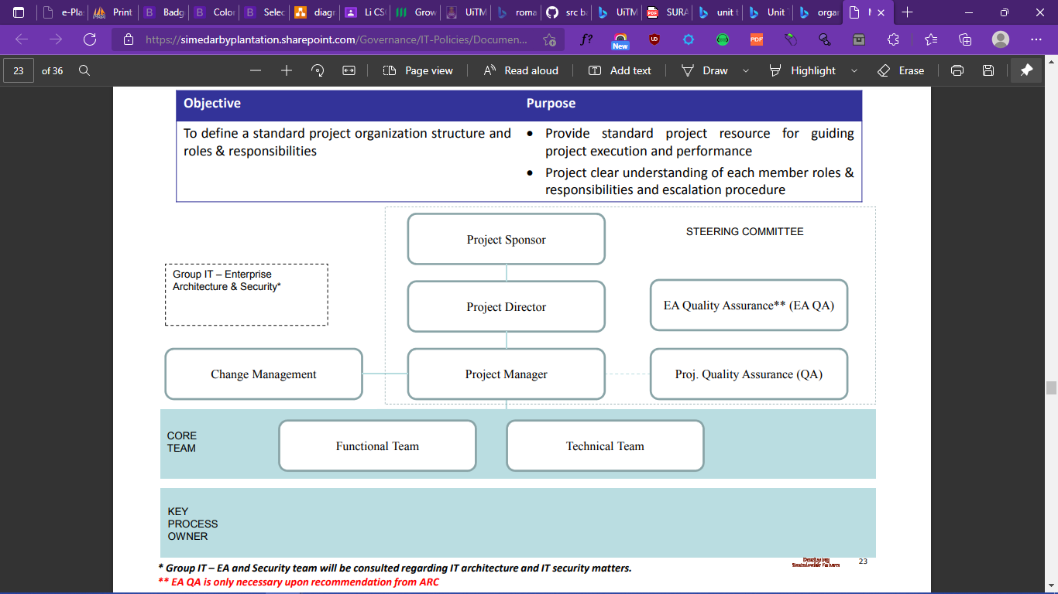

(Figure 1)

**3.0 System Planning**

* 1. **Introduction**

To plan on developing the current/existing system for process of volunteer to make it easily find and join volunteering program, and that will help user/volunteer manage their time and cost more effective.

* 1. **Description of the Current/Existing System**

User/Volunteer:

1. The user/volunteer search for volunteering program and register their info to join the program.
2. Wait for the volunteering program to call/message to help volunteering.
3. Join Volunteering Program and help the program based on the task information

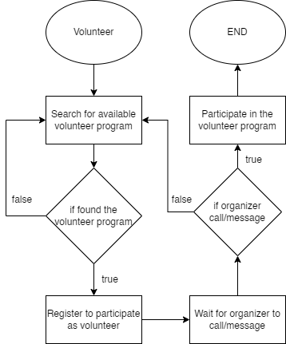

(Figure 2)

Volunteering program organizer:

1. Create a volunteering program.
2. Searching for volunteer to join their volunteering program and must keep track of the volunteer information.
3. Call/message volunteer to inform the volunteering program information.
4. Keep track of volunteer and give them their tasks

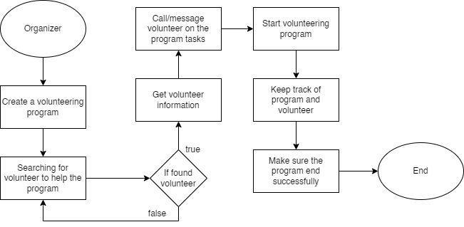

(Figure 3)

* 1. **Main Reason of the System Project**

The main reason of the system project is to make the current existing system much easier to use for volunteer and will help keep track of the volunteer activities.

Another reason is to easily let volunteer to give suggestions on what volunteering program would be, and the future volunteering program will be selected based on the majority vote from suggestions and volunteer organizer would choose it to organize it.

* 1. **Feasibility Study**
     1. **Operational**

The proposed system would get the input from user and would generate the output automatically based on the information given.

* + 1. **Technical**

Software Use: XAMPP Server, MYSQL, PHP, Browser (Microsoft Edge, Google Chrome, etc.)

Hardware Use: Intel Core i5 with 64-Bit Operating System, 8 GB RAM and Window 10 Enterprise

* + 1. **Economic**

Year-one install and setup cost: RM 4,000

Year-one new hardware required: RM 5,000 (Hardware life expectancy in years: 7 years)

Additional hardware cost each year: RM 3,000  
Recurring other costs(annual): RM 1,000  
Year 1: RM 10,000  
Year 2 until Year 10: RM 4,000

* + 1. **Schedule**

As seen in Figure 4 below:

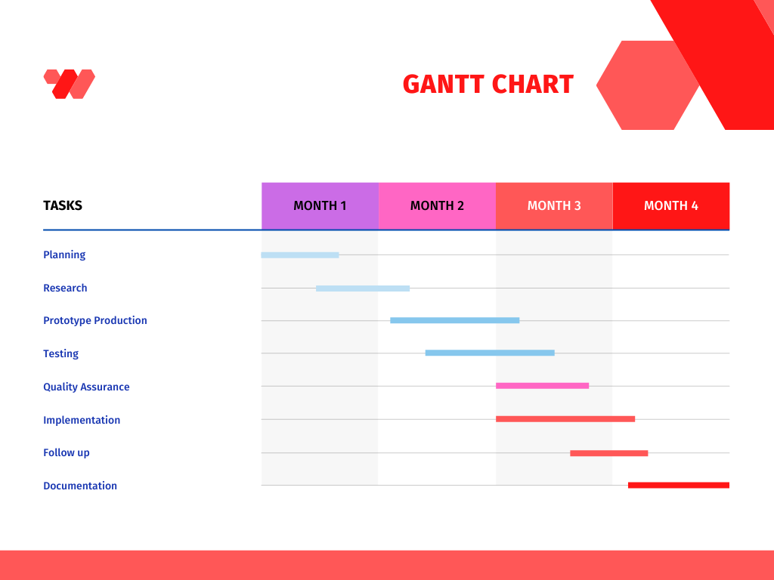

(Figure 4)

**4.0 System Analysis and Design**

* 1. **Introduction**

eVolunteer is a web based-application system that will help the volunteer communities to easily suggests what type of volunteering program that organizer should do, which the organizer to keep track on the majority vote for the suggestions and can either accept the volunteer suggestion or adjust a bit for the suggestion and approve it to be made as a volunteering program, while user can choose to participate with the volunteering program or not.

* 1. **System** **requirements**
     1. **System** **Objectives**

The objective of the system is to get the necessary input from the user and display the output of the input as clean and user friendly as possible, while making the system more engaging by letting the user to post suggestions and voting and having addition features such as achievement to make user who keen on completing missions to keep them from boredom and feel the system is much more fun and easier to use.

* + 1. **System** **Scope**
       1. **Functional** **requirements**

1. Calculation:
2. Calculate the vote for the suggestions.
3. Calculate the user login count.
4. Calculate the time and date and send notifications to volunteer that participant in the volunteering program based on the start date.
5. Input:
6. Get user input for registration and login.
7. Get user input for specific task, such as getting input for posting suggestions.
8. Get user input from clicking vote/participate.
9. Get user input for editing the posted suggestions.
10. Get user input for clicking to another page.
11. Warning message:
12. Send a warning message when user use incorrect login credentials.
13. Send a warning message when user breach the terms and conditions and guidelines.
14. Send a warning message when user entering a page that does not in line with the user group permissions.
15. Congratulation message:
16. Get a message on successful register/login.
17. Get a message on successful post suggestions.
18. Get a message on participating on volunteering program.
19. Get a message on getting achievements.
    * + 1. **Functional** **requirements**
20. User friendly interface:
21. Clean user interface without non-informative information.
22. Minimalist and simplicity for the user interface, to make user feels at ease to use.
23. User interface theme that is very attractive and fresh for user.
24. Security:
25. Every user password is encrypted and stored securely into the database system.
26. User inputs are strictly monitored by the input function to ensure attackers can’t harm the system.
27. Making sure the system is being accessed from browser instead of other platforms, to put extra security.
28. Making sure to add extra security for possible spams input from unethical user.
    * 1. **System** **Requirement** **specification**
         1. **Input** **requirement**
29. Doesn’t accept special characters for user credentials (login).
30. User can use the markdown features to make their posts much more attractive and informational.
31. Filter out the spam, such as all messages are capitalized, or the message are full of the same word.
    * + 1. **Output** **requirement**
32. Output is to be format and change based on the data given.
33. Output is to be user friendly, which doesn’t have any misalign with the user screen display.
    * + 1. **Process** **Requirement**
34. Process is to make sure the data type is correct before processing it.
35. Process must be accurate and functioning.
36. Process must be fast.
    * + 1. **Security** **and control requirement**
37. The confidential data is to be encrypt using the latest technology and algorithms before storing it at a secure database.
38. Using a prevention method for any possible bots to gain access to the systems.
39. Strictly monitor the systems to make sure there is no security issues that could happen
40. Update any possible algorithms to keep up to date, to ensure the system is up to date.
    1. **Process** **Modelling**
       1. **Context** **Diagram**

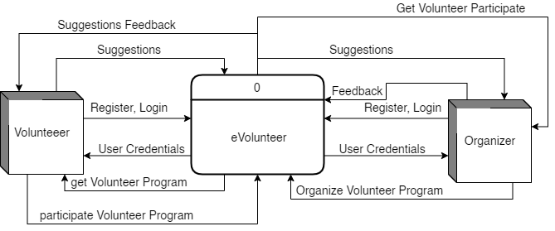

(Figure 5)

* + 1. **Data Flow Diagram 0**

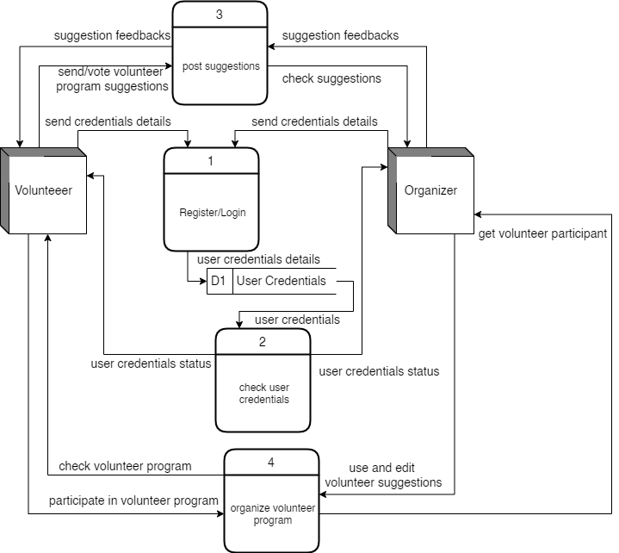

(Figure 6)

* 1. **Data Modeling** 
     1. **Entity Relationship Diagram/ERD**

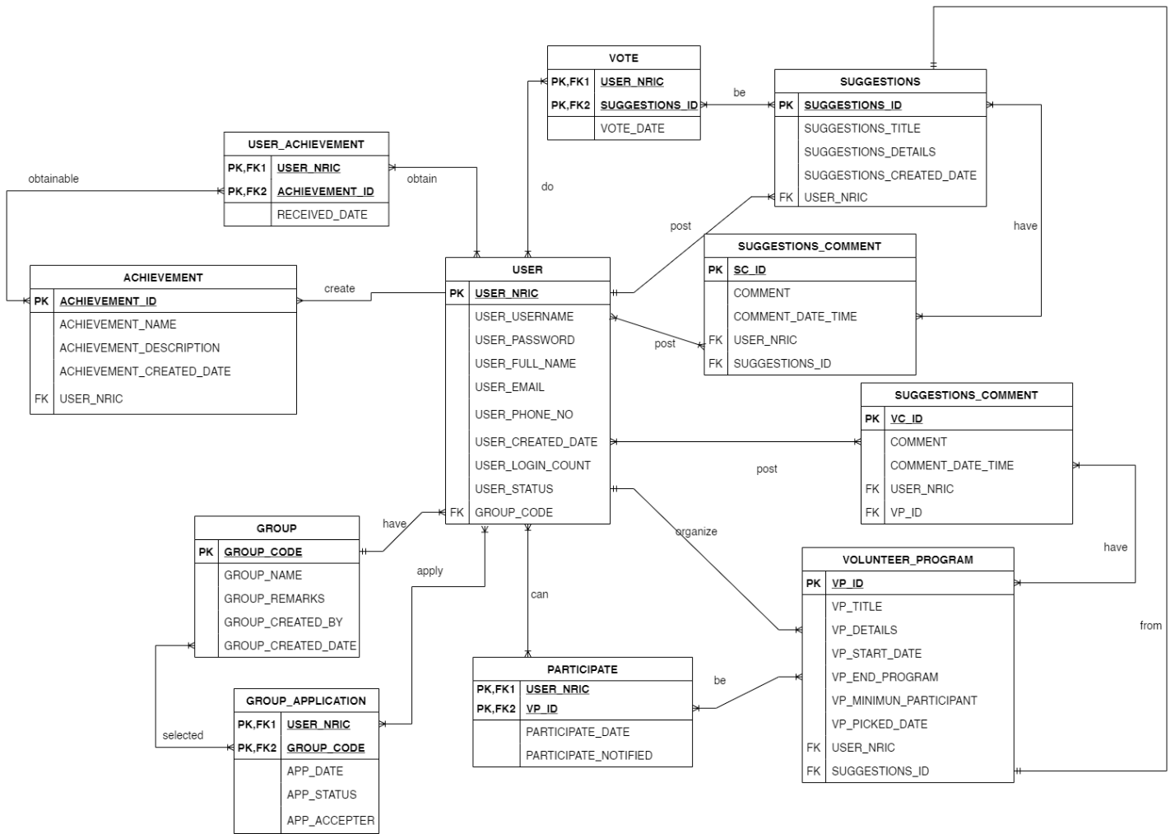

(Figure 7)

* + 1. **Relational schema**

USER(USER_NRIC, USER_USERNAME, USER_PASSWORD, USER_FULL_NAME, USER_EMAIL, USER_PHONE_NO, USER_CREATED_DATE, USER_LOGIN_COUNT, USER_STATUS, GROUP_CODE*)

GROUP(GROUP_CODE, GROUP_NAME, GROUP_REMARKS, GROUP_CREATED_BY, GROUP_CREATED_DATE)

GROUP_APPLICATION(USER_NRIC*, GROUP_CODE*, APP_DATE, APP_STATUS, APP_ACCEPTER)

ACHIEVEMENT(ACHIEVEMENT_ID, ACHIEVEMENT_NAME, ACHIEVEMENT_DESCRIPTION, ACHIEVEMENT_CREATED_DATE, USER_NRIC*)

USER_ACHIEVEMENT(USER_NRIC*, ACHIEVEMENT_ID*, RECEIVED_DATE)

SUGGESTIONS(SUGGESTIONS_ID, SUGGESTIONS_TITLE, SUGGESTIONS_DETAILS, SUGGESTIONS_CREATED_DATE, USER_NRIC)

VOTE(USER_NRIC*, SUGGESTIONS_ID*, VOTE_DATE)

SUGGESTIONS_COMMENT(SC_ID, COMMENT, COMMENT_DATE_TIME, USER_NRIC*, SUGGESTIONS_ID*)

VOLUNTEER_PROGRAM(VP_ID, VP_TITLE, VP_DETAILS, VP_START_DATE, VP_END_PROGRAM, VP_MINIMUM_PARTICIPANT, VP_PICKED_DATE, USER_NRIC*, SUGGESTIONS_ID*)

PARTICIPATE(USER_NRIC*, VP_ID*, PARTICIPATE_DATE, PARTICIPATE_NOTIFIED)

VP_COMMENT(VC_ID, COMMENT, COMMENT_DATE_TIME, USER_NRIC*, VP_ID*)

1. **System Implementation**
   1. **Input Interface**
2. Registration

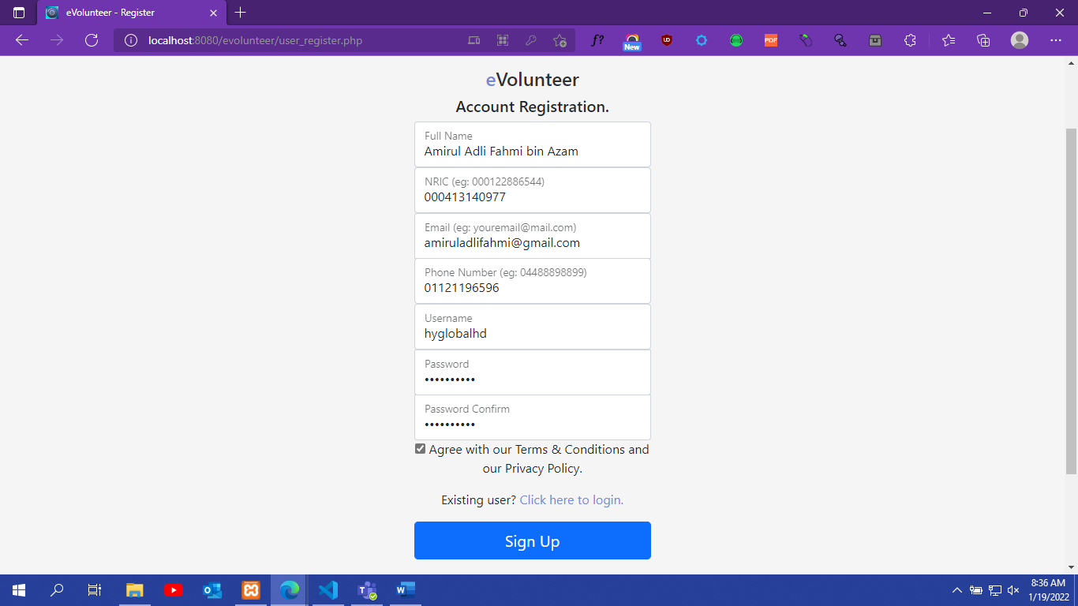

1. Login

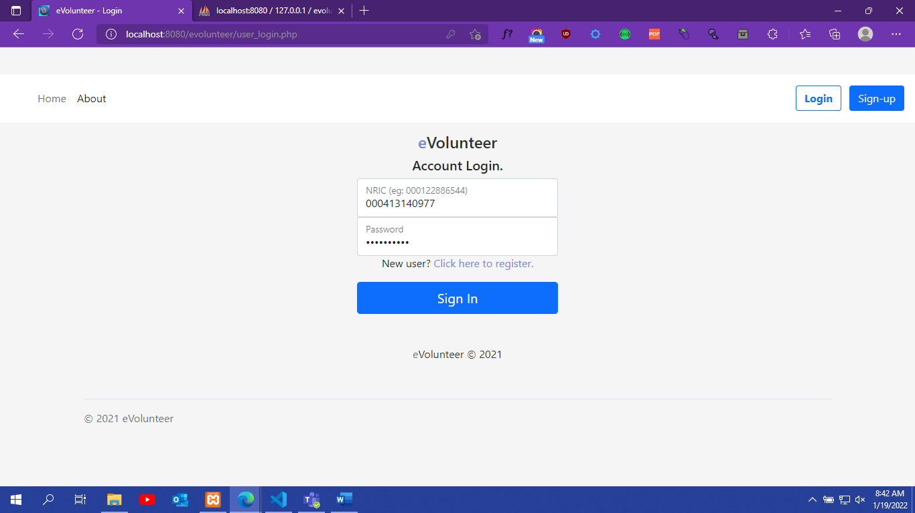

1. Create Suggestions

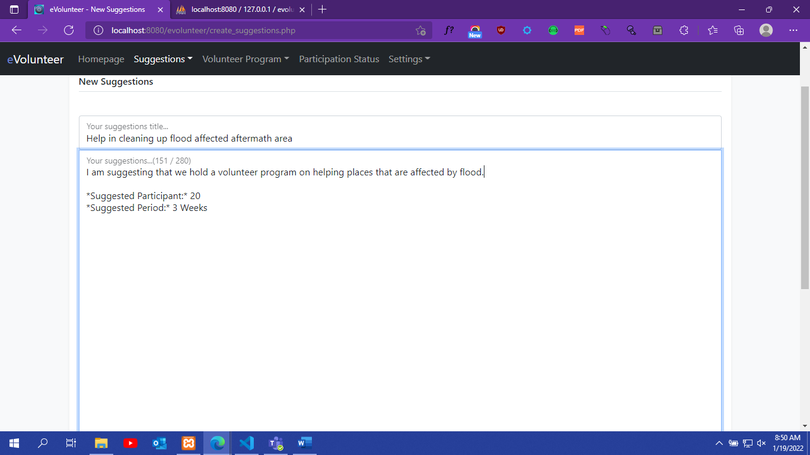

1. Edit/Delete Suggestions

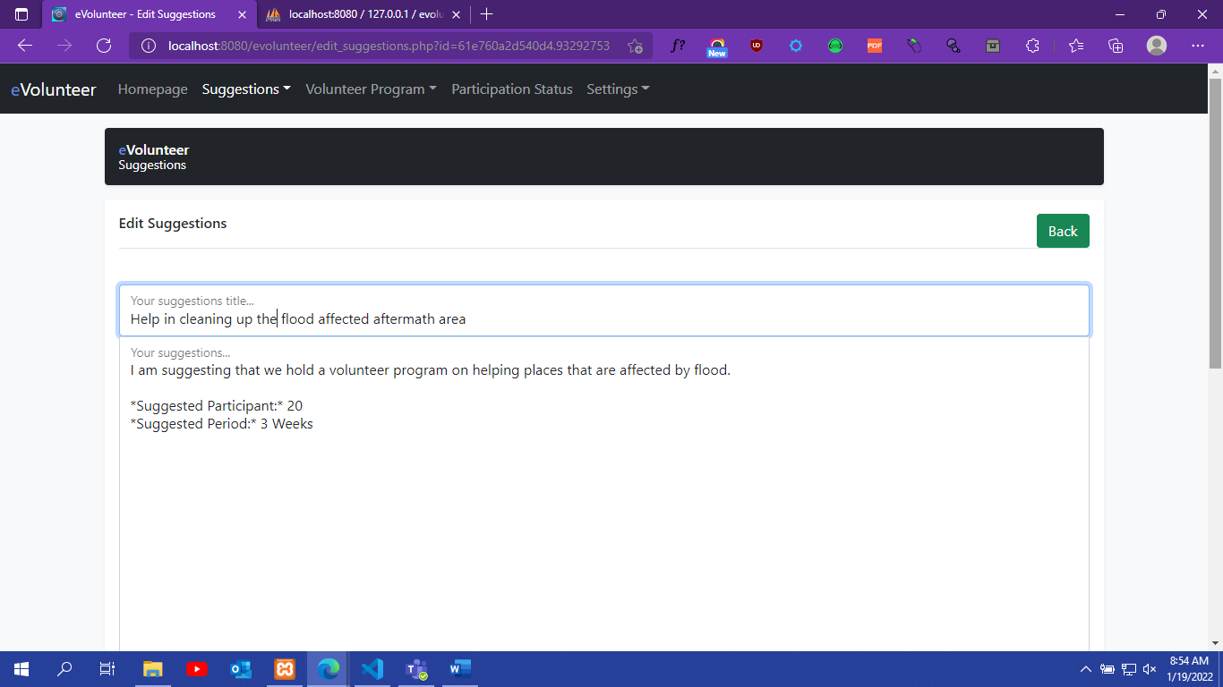

1. Vote/UnVote

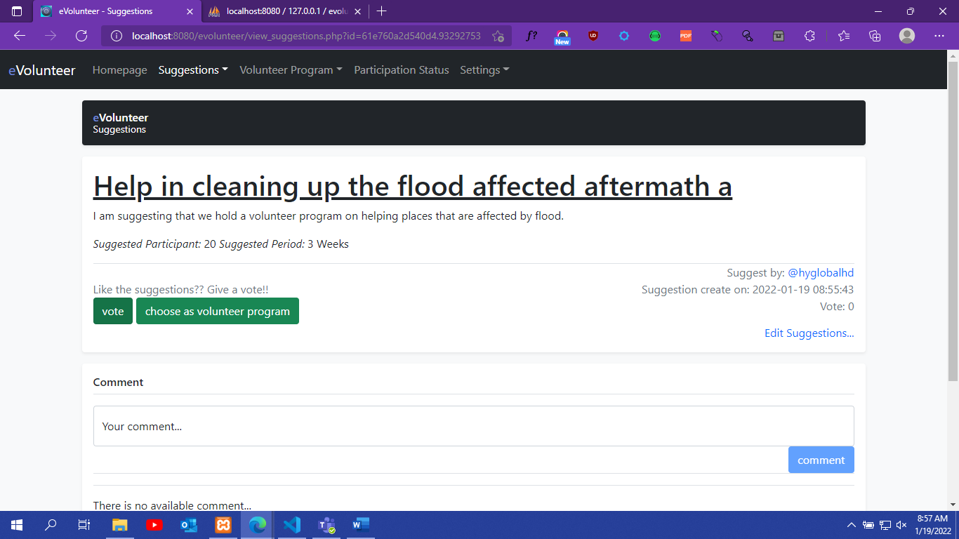

1. New Suggestions Comment

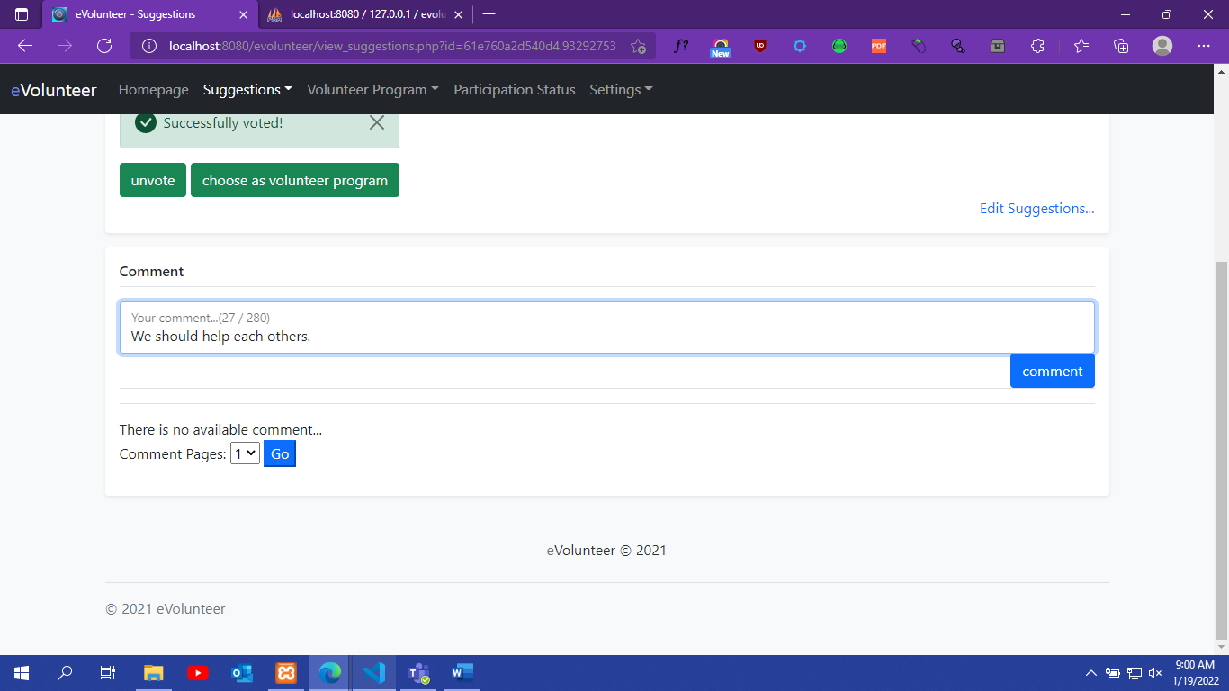

1. Edit/Delete Suggestions Comment

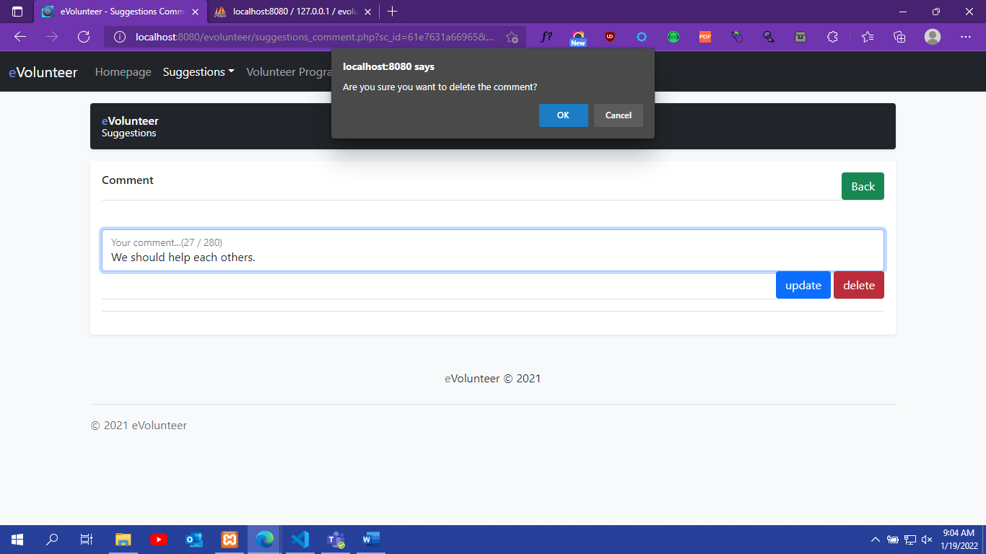

1. Create Volunteer Program

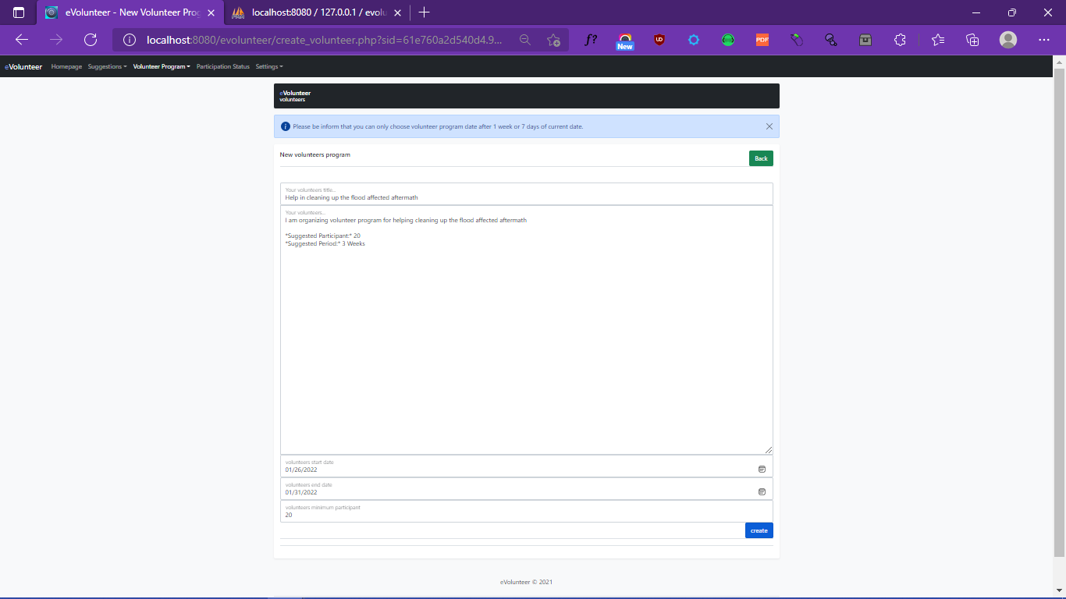

1. Edit/Delete Volunteer Program

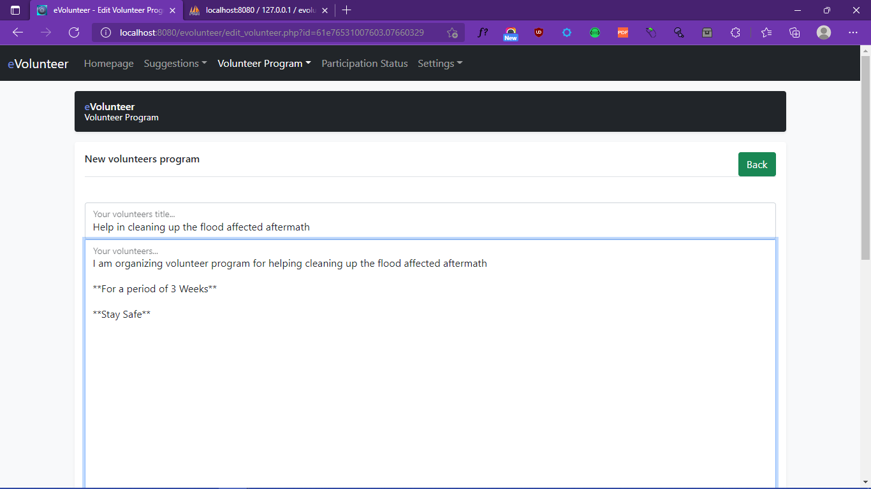

1. Participate/UnParticipate Volunteer Program

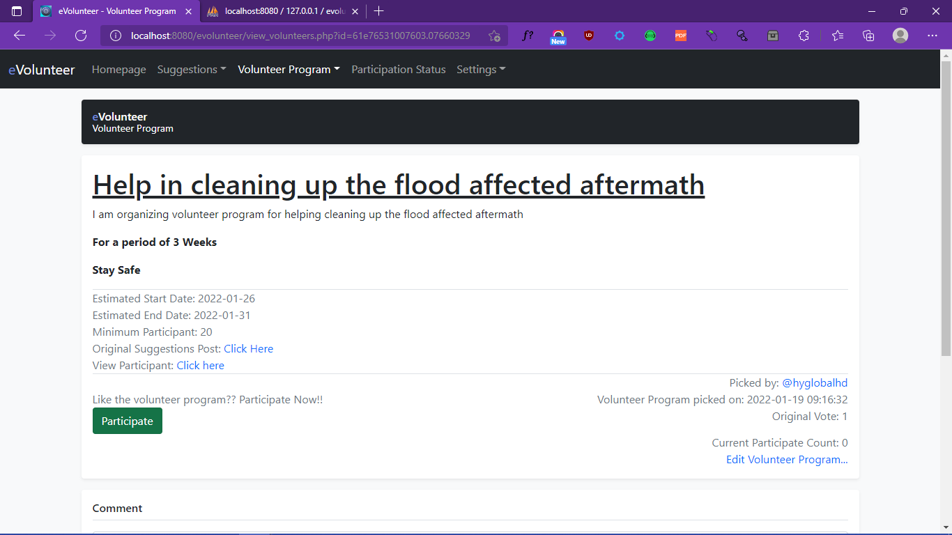

1. New Volunteer Program Comment

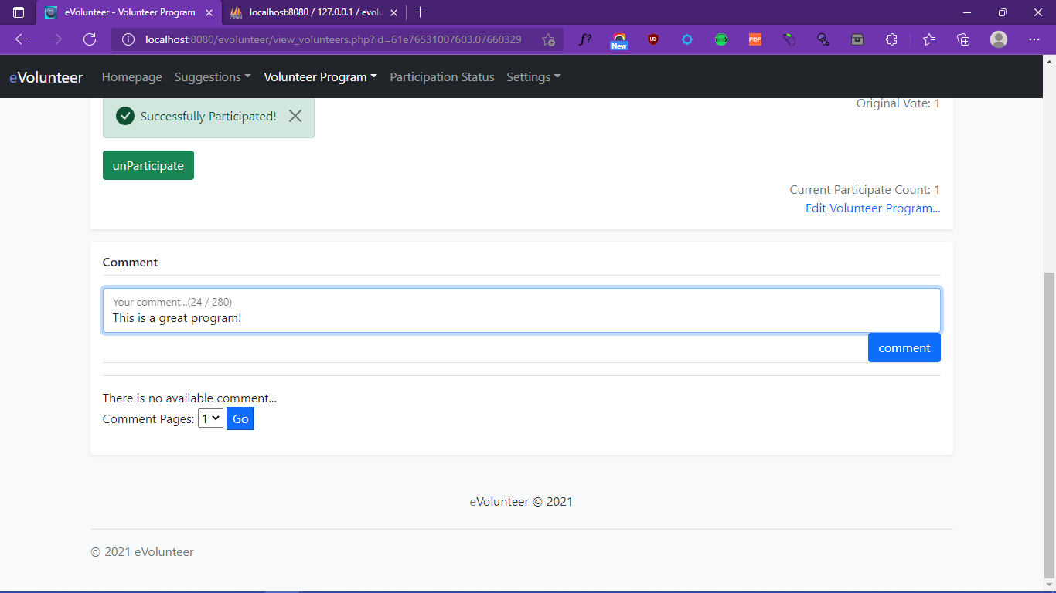

1. Edit/Delete Volunteer Program Comment

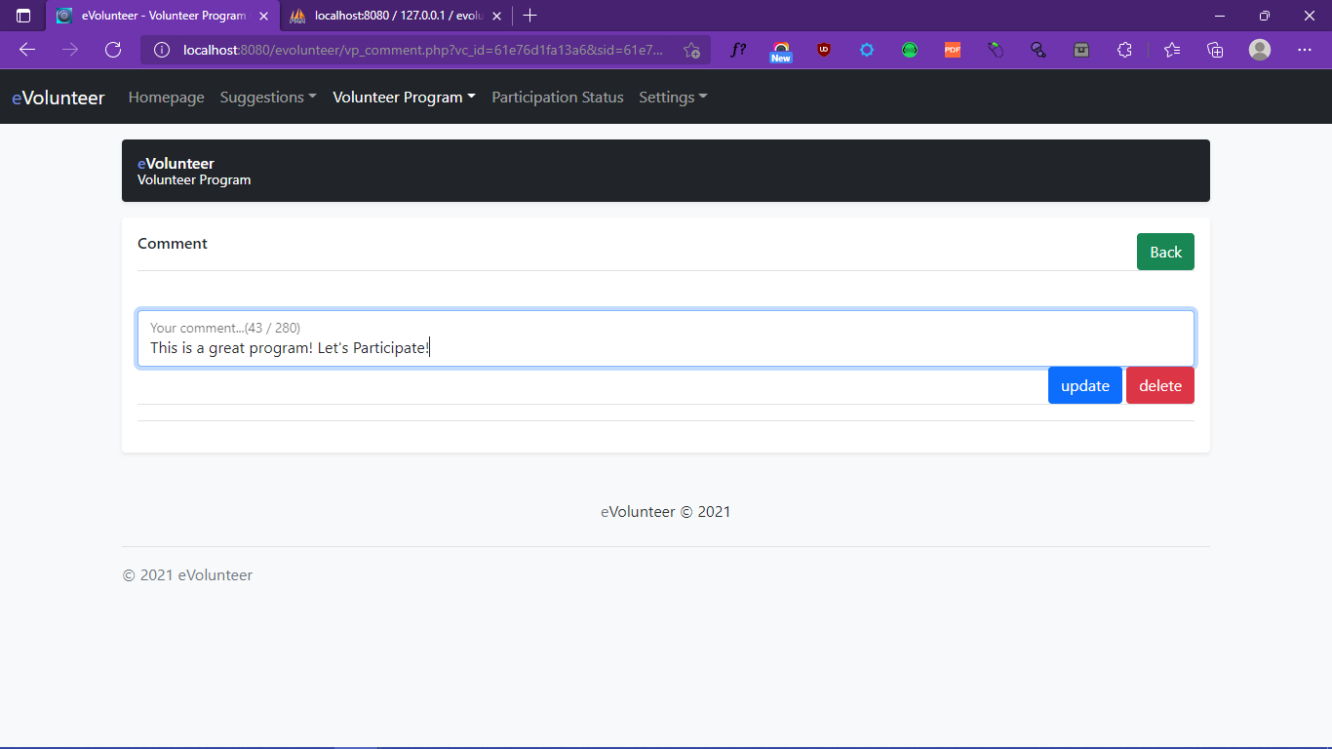

1. Search Suggestions

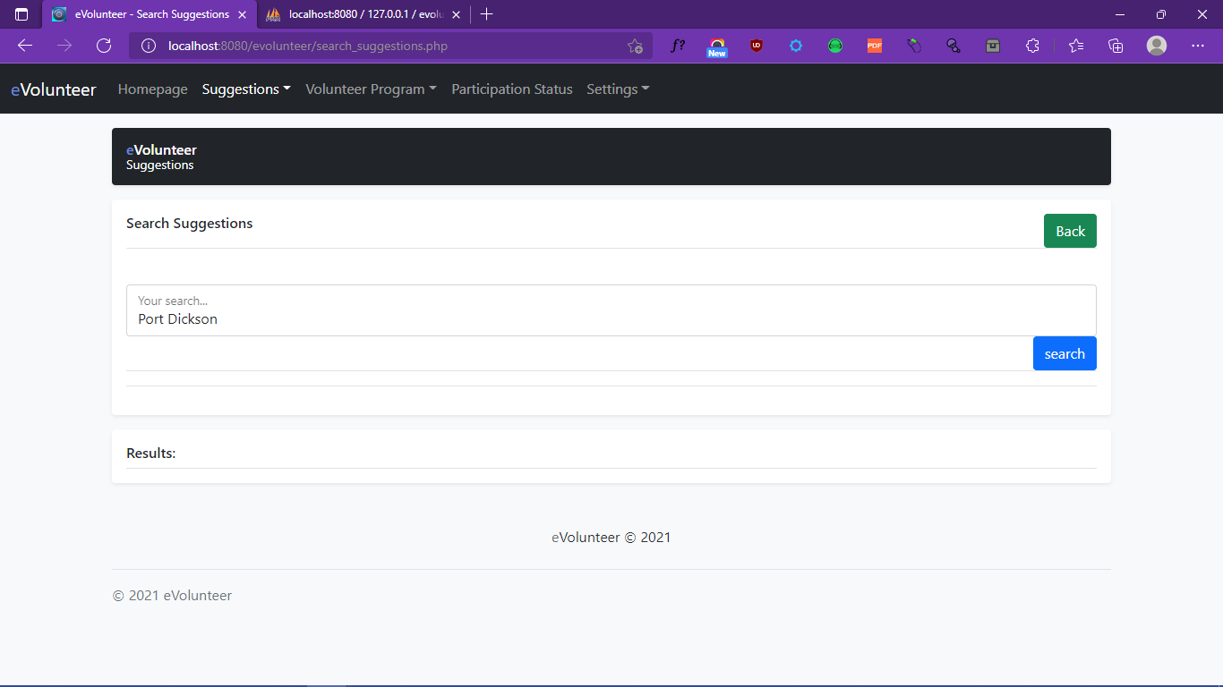

1. Search Volunteer Program

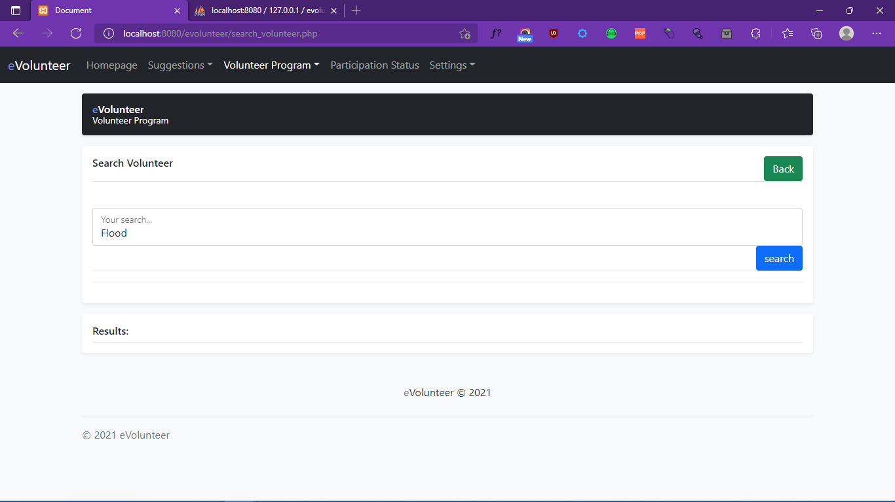

1. Update User Profile

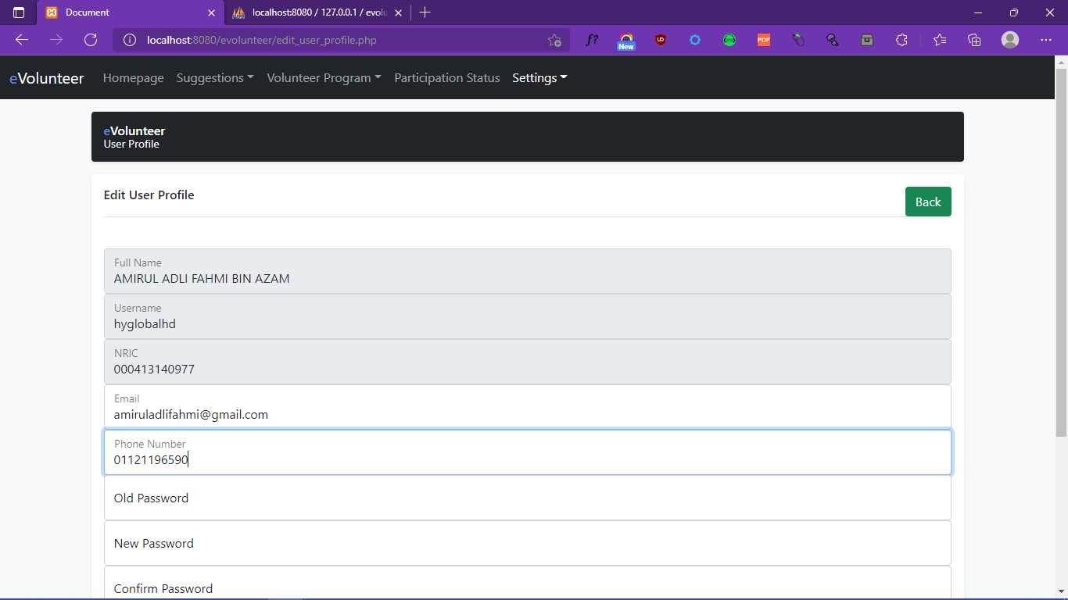

1. Group Application Apply

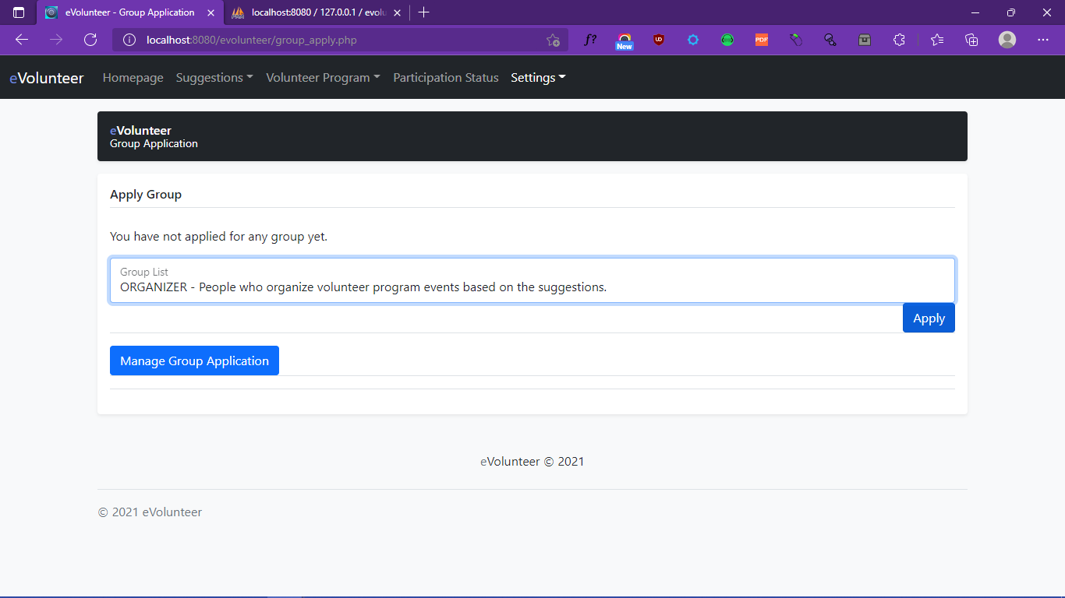

1. Admin Group Application Edit

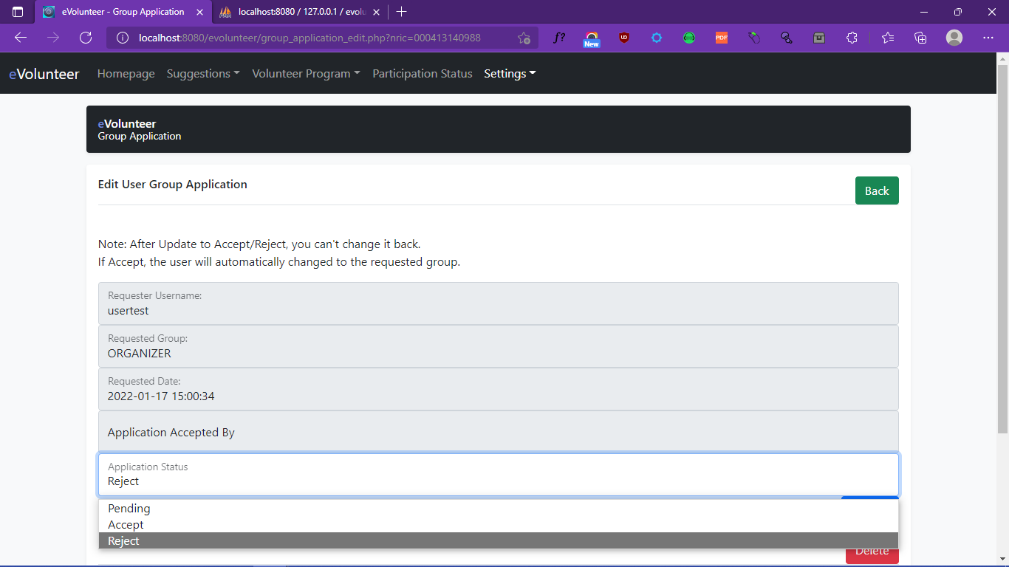

1. User Group Application Cancel

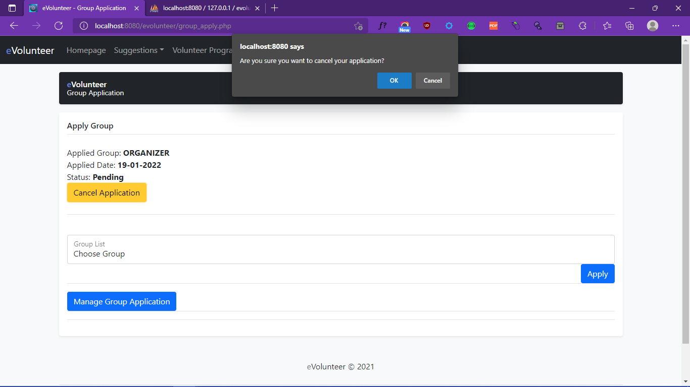

1. Ban/UnBan User

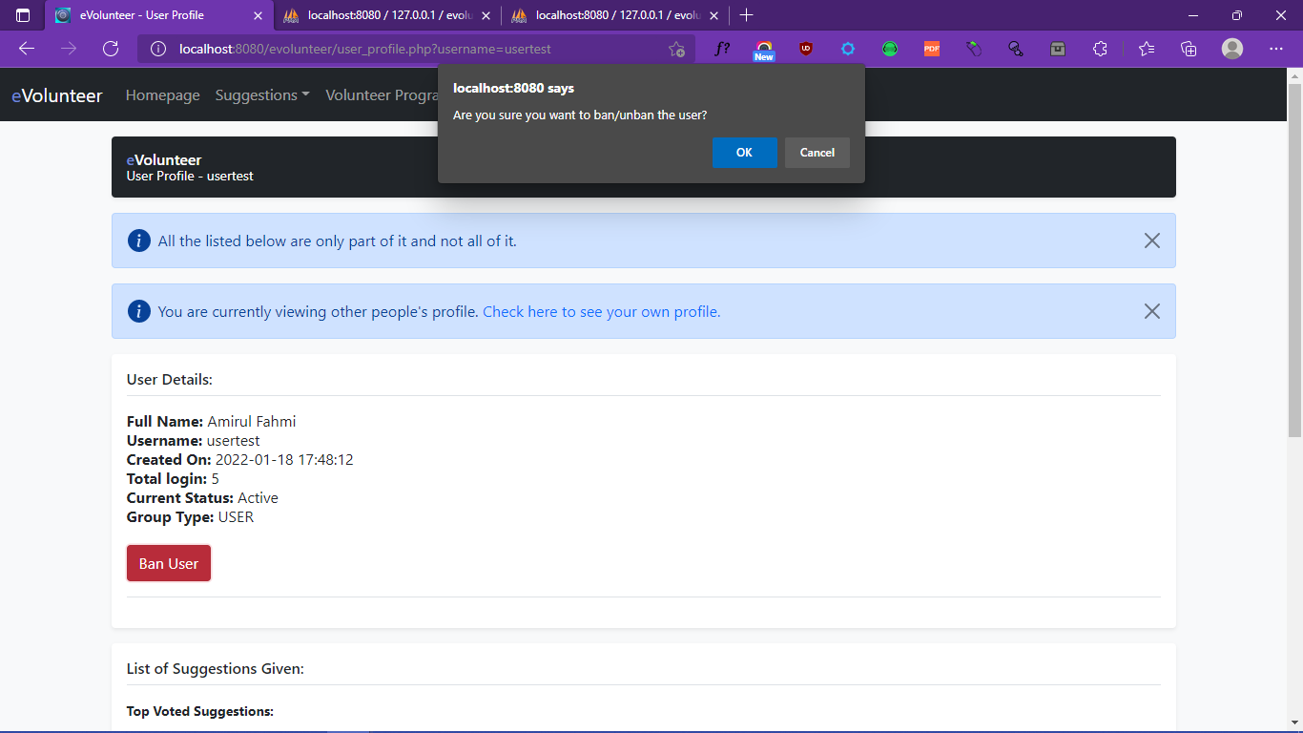

xxx. Create Achievement

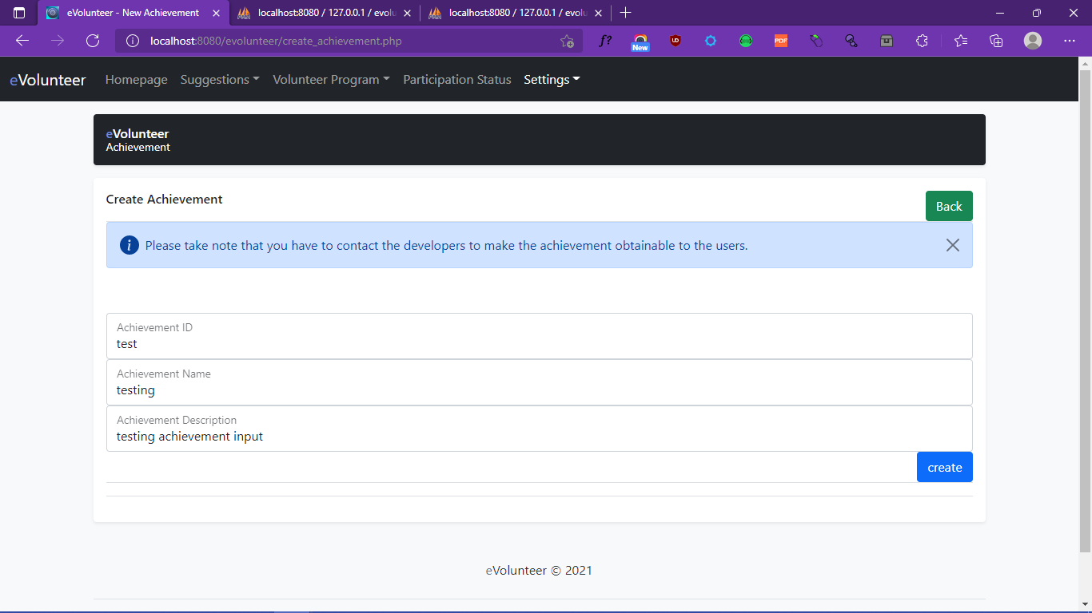

xxxi. Logout

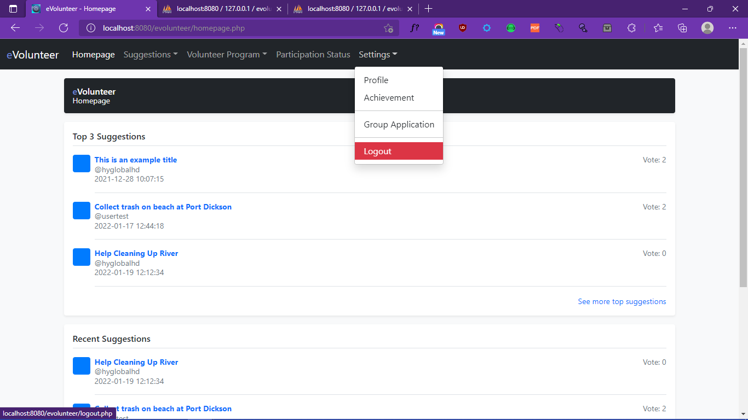

* 1. **Output Interface**

1. Registration

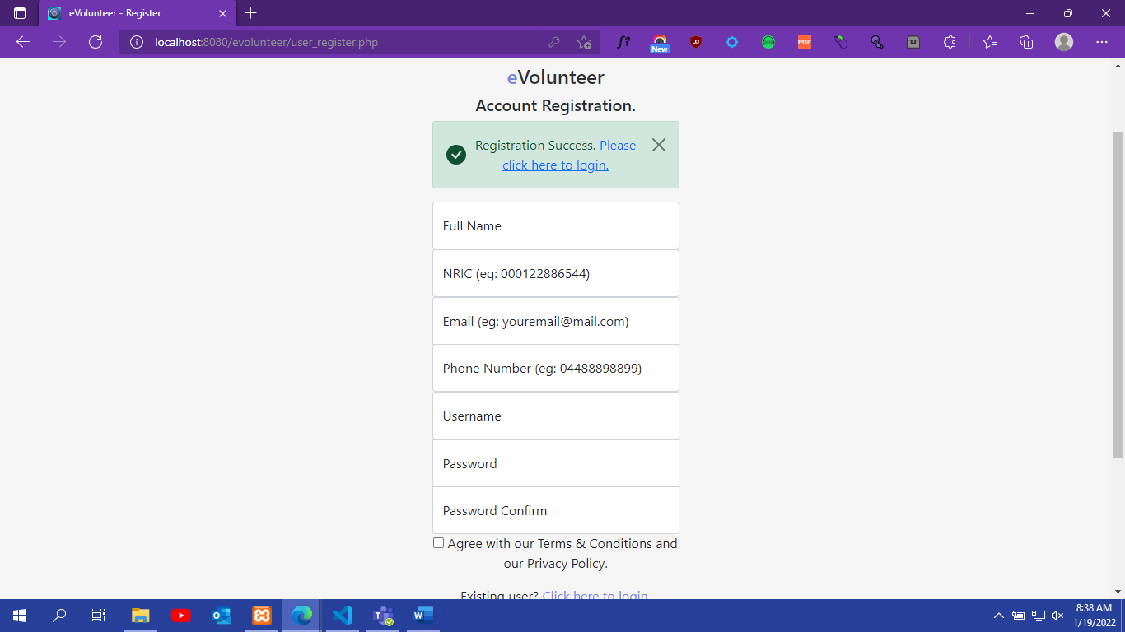

1. Login

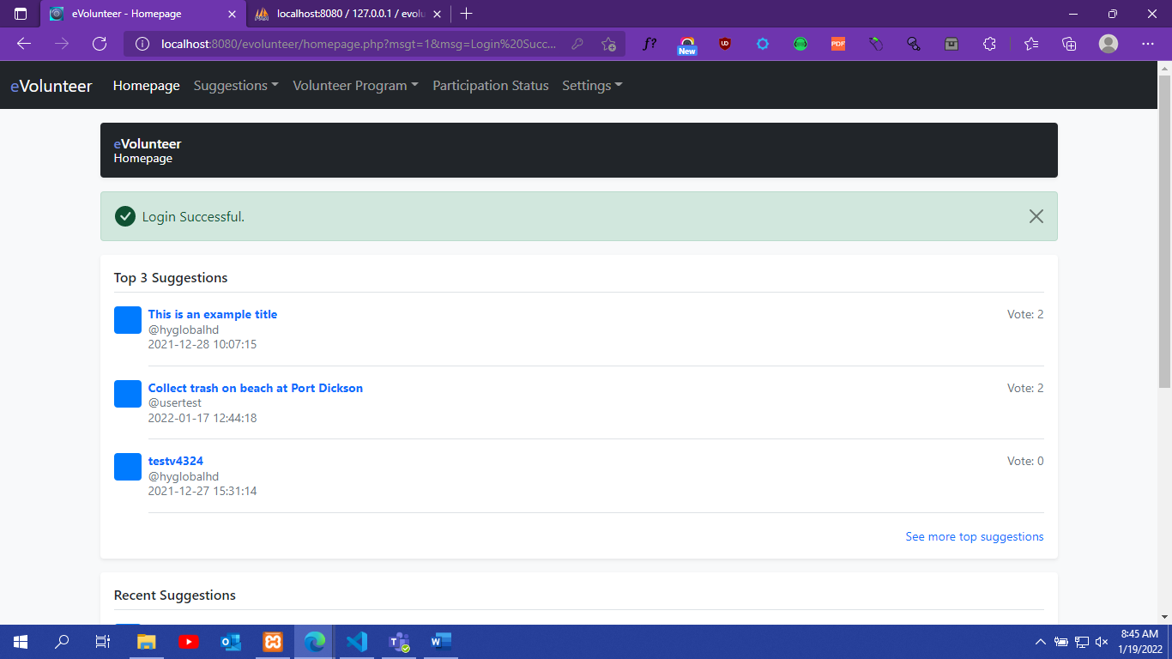

1. Create Suggestions

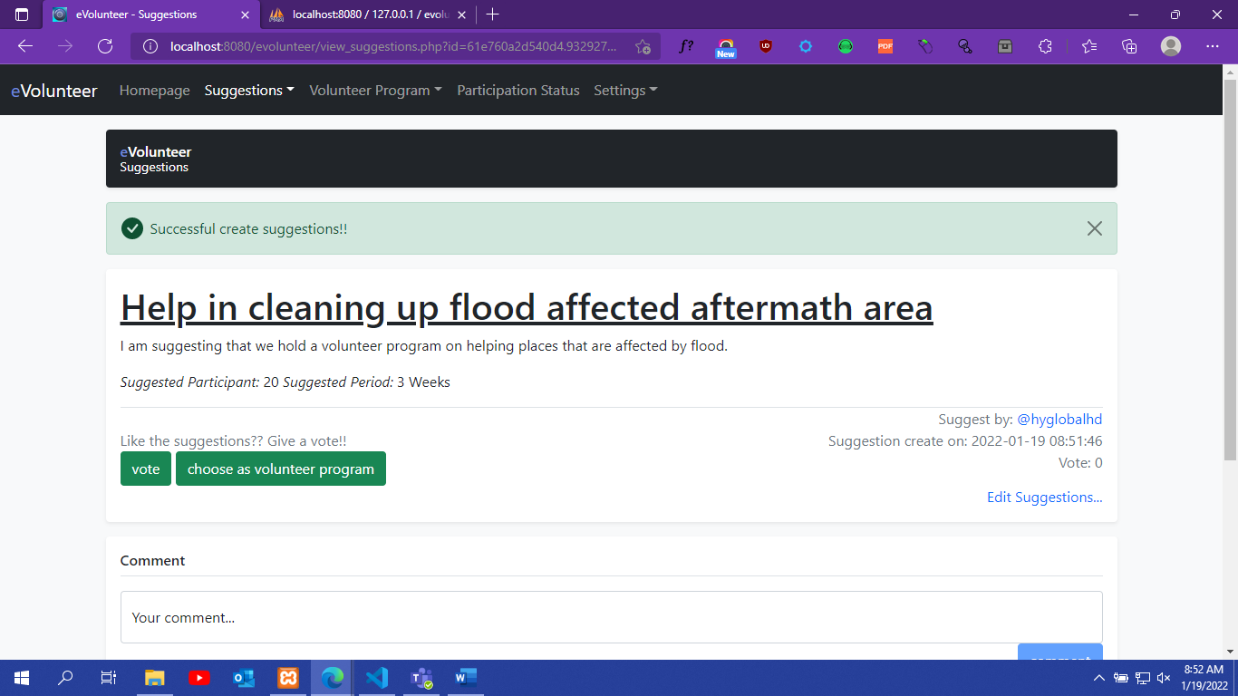

1. Edit/Delete Suggestions

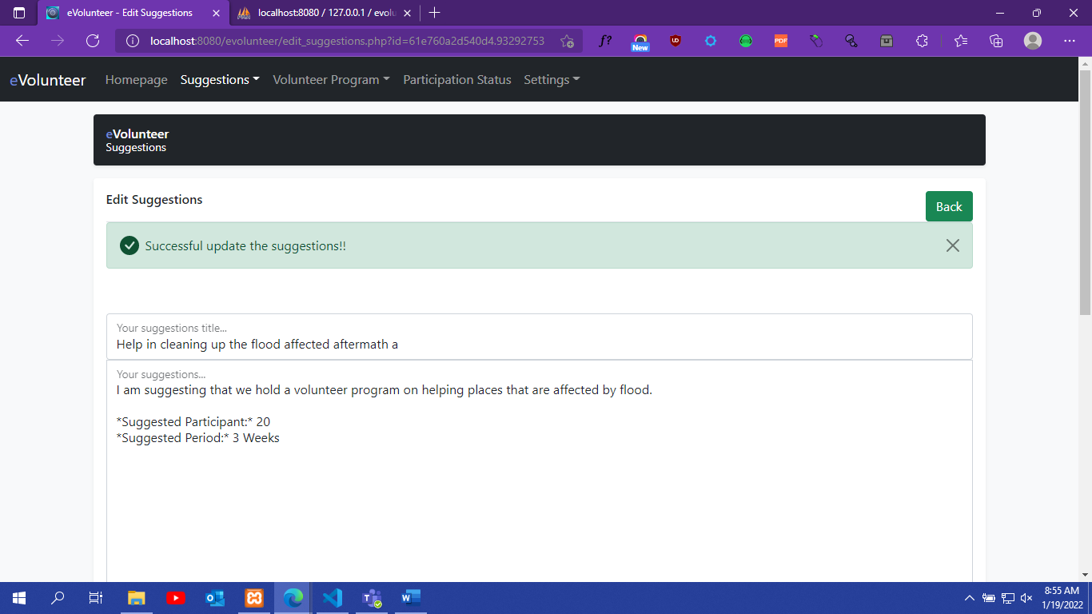

1. Vote/UnVote

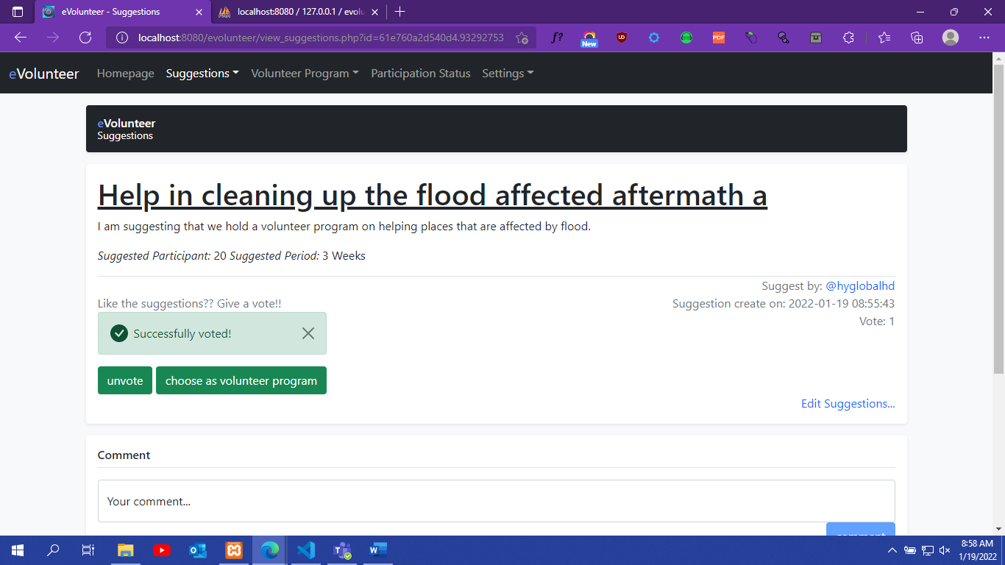

1. New Suggestions Comment

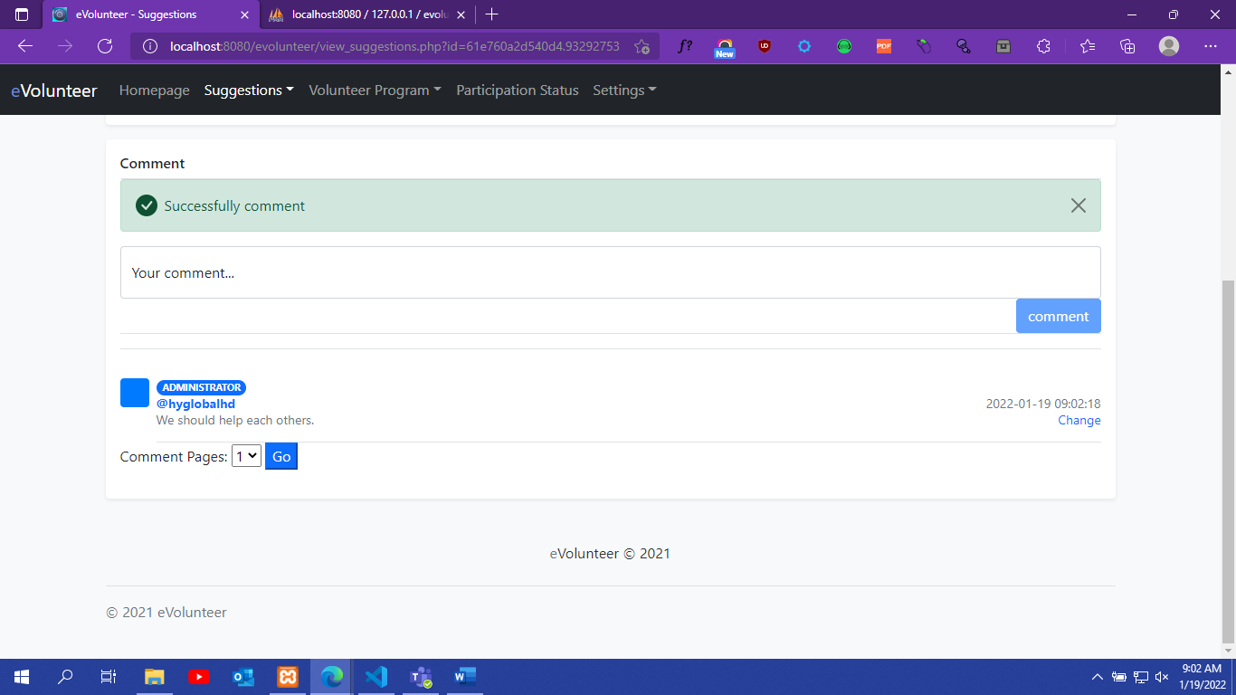

1. Edit/Delete Suggestions Comment

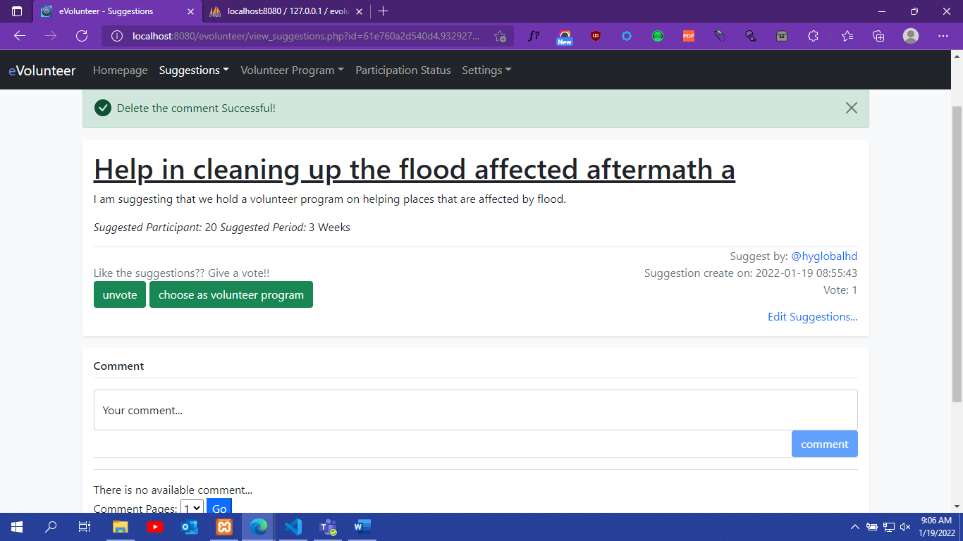

1. Create Volunteer Program

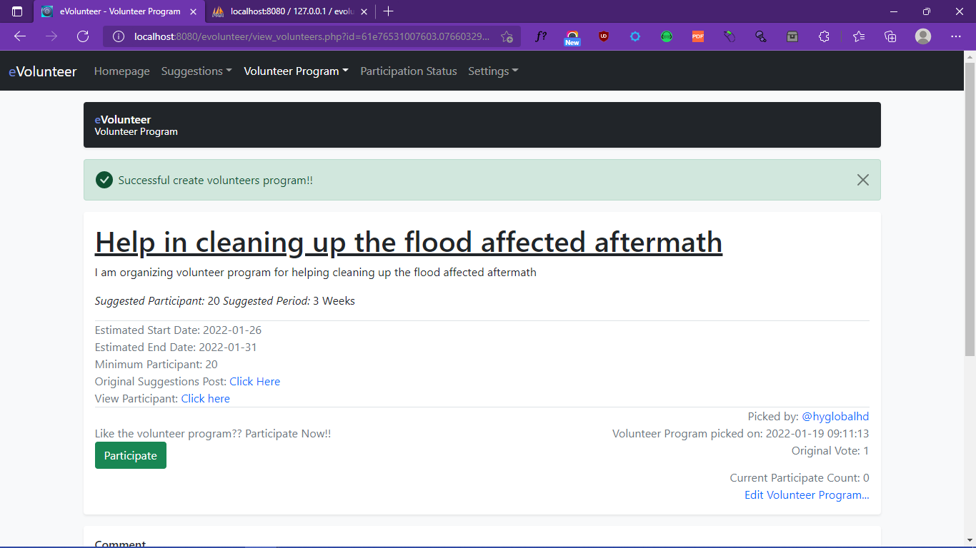

1. Edit/Delete Volunteer Program

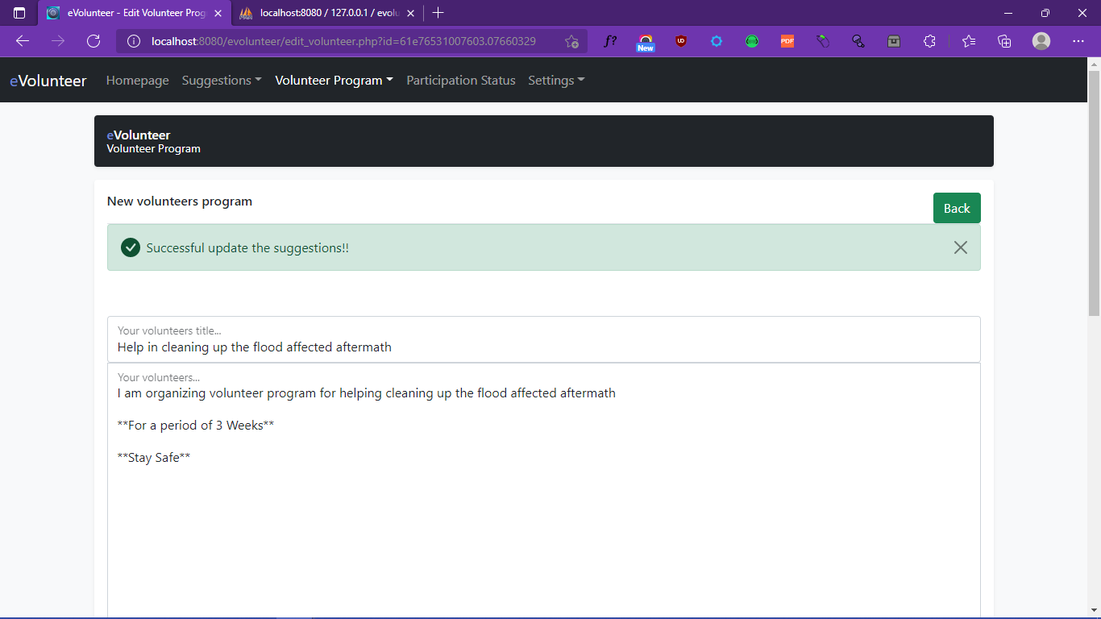

1. Participate/UnParticipate Volunteer Program

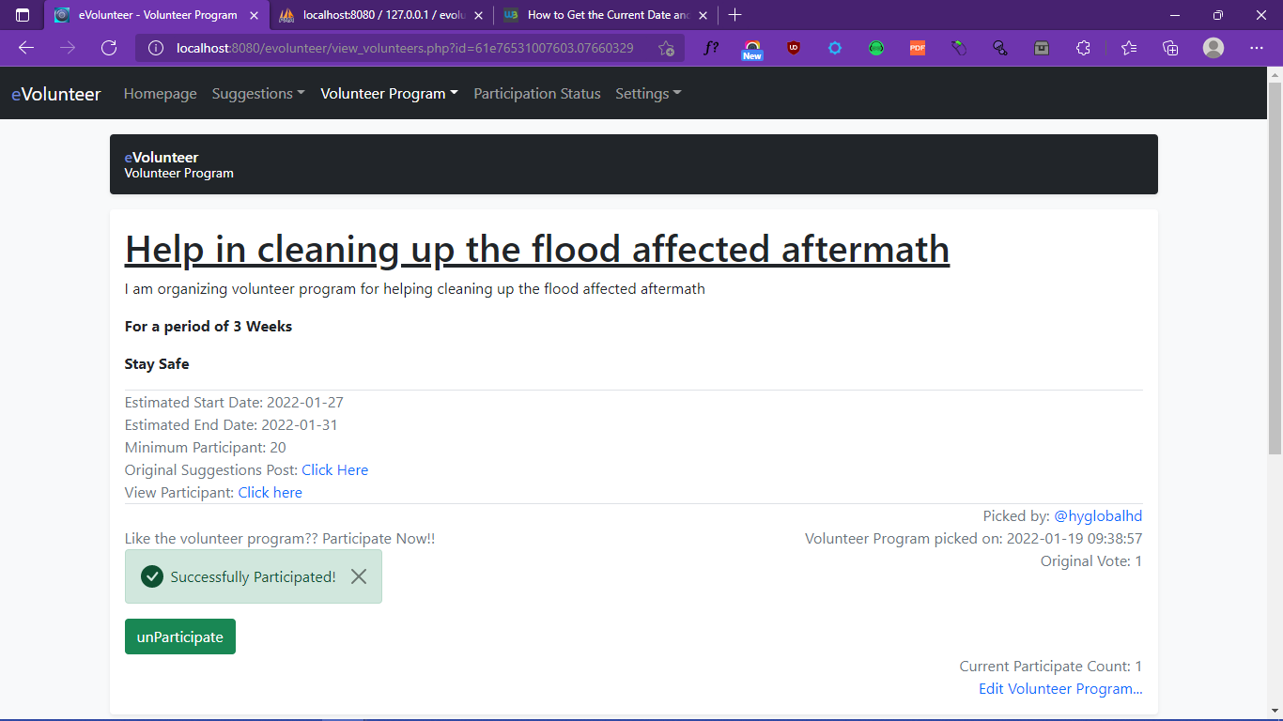

1. New Volunteer Program Comment

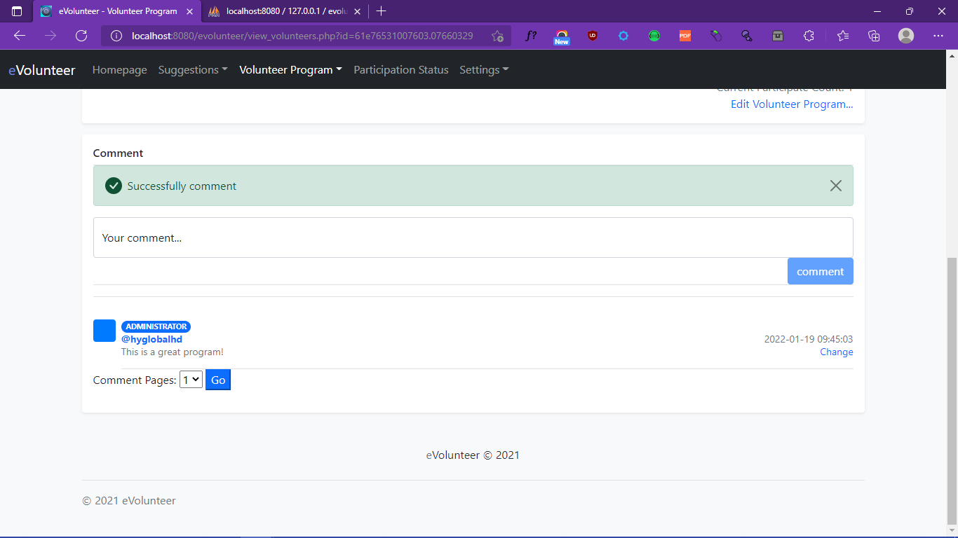

1. Edit/Delete Volunteer Program Comment

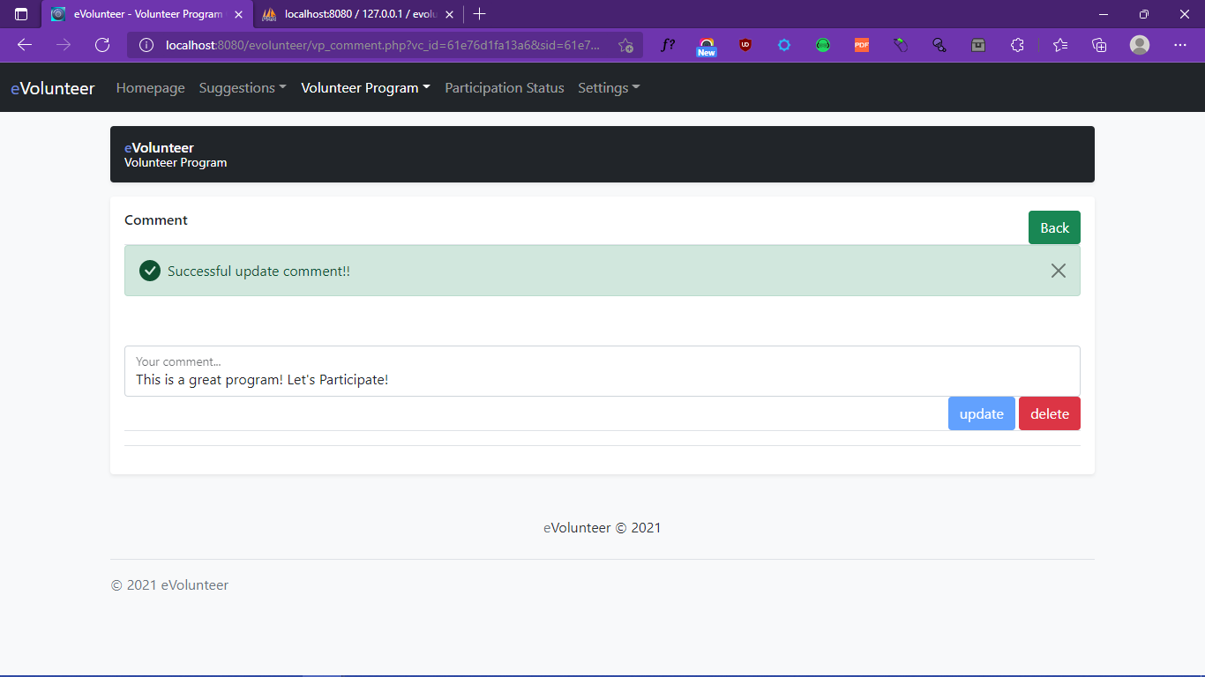

1. Search Suggestions

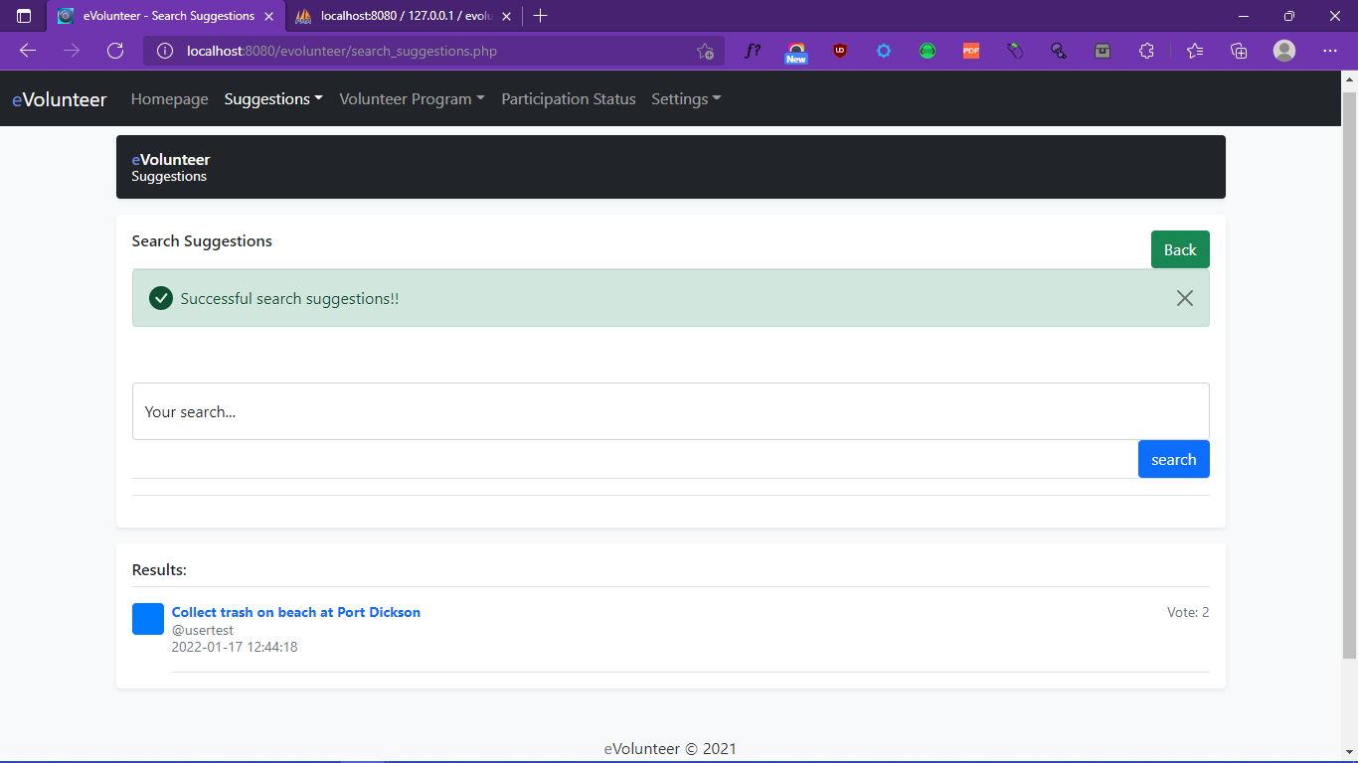

1. Search Volunteer Program

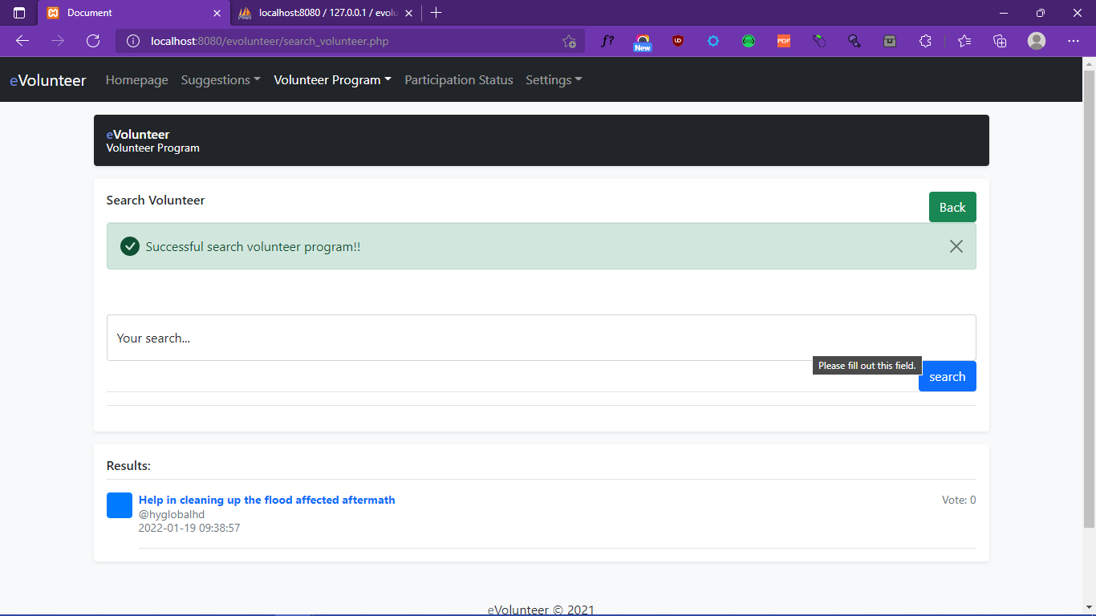

1. Update User Profile

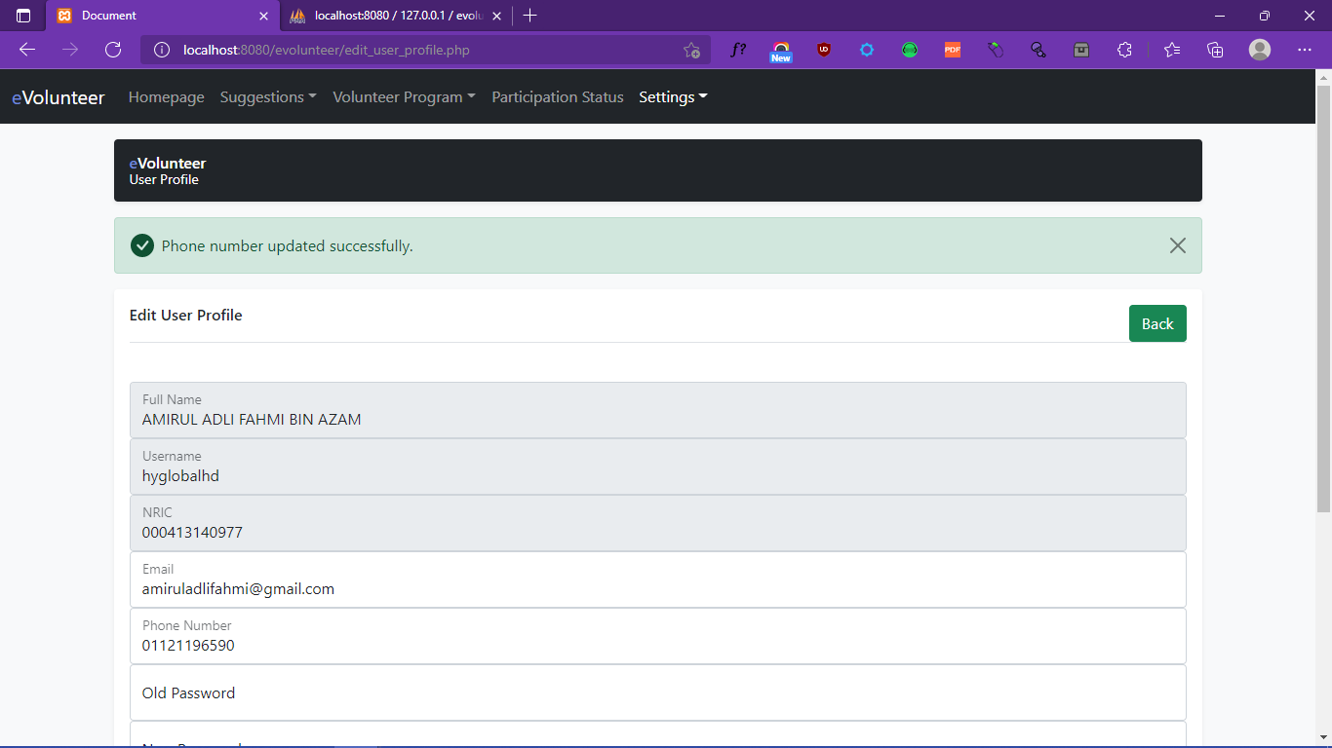

1. Group Application Apply

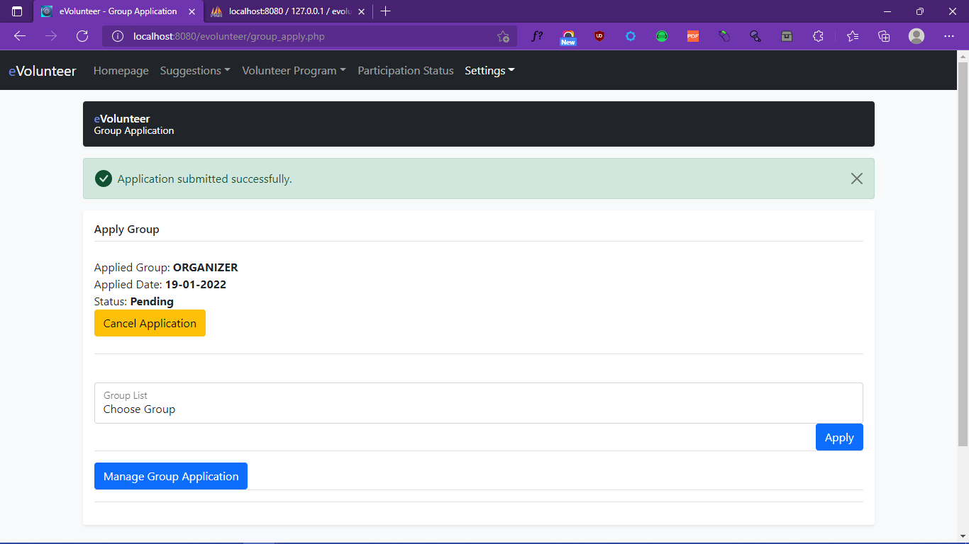

1. Admin Group Application Edit

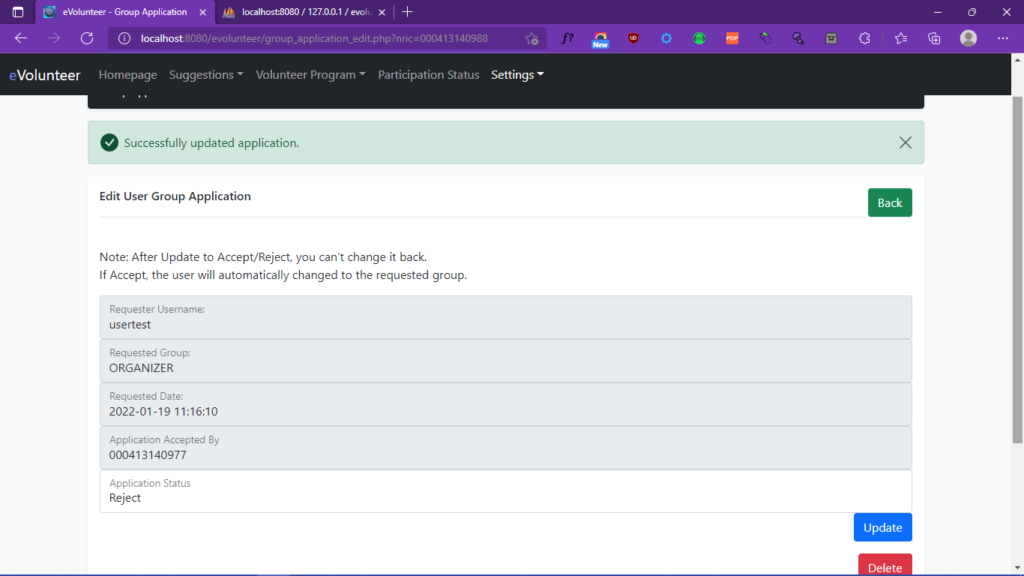

1. User Group Application Cancel

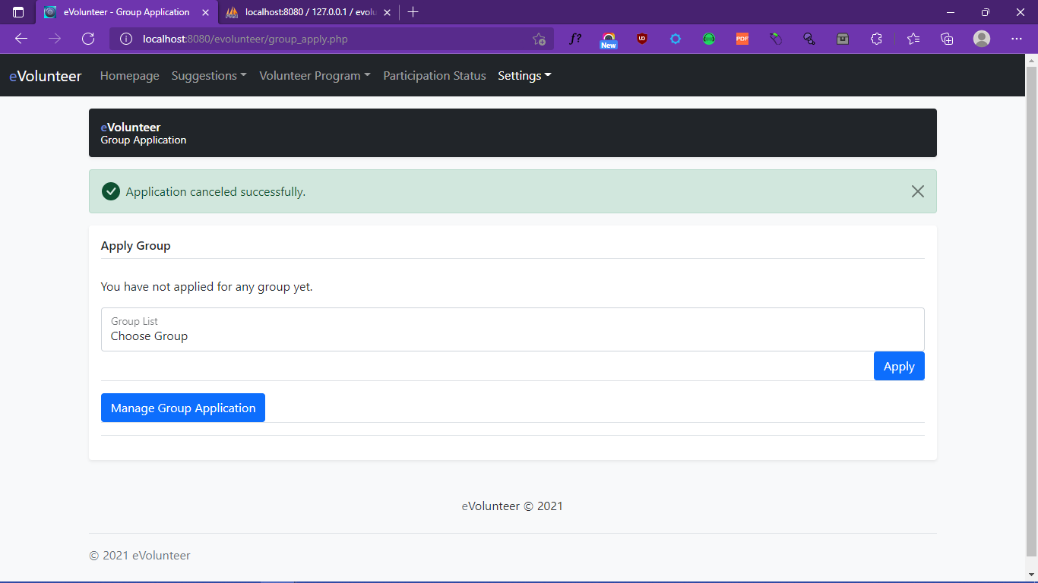

1. Homepage

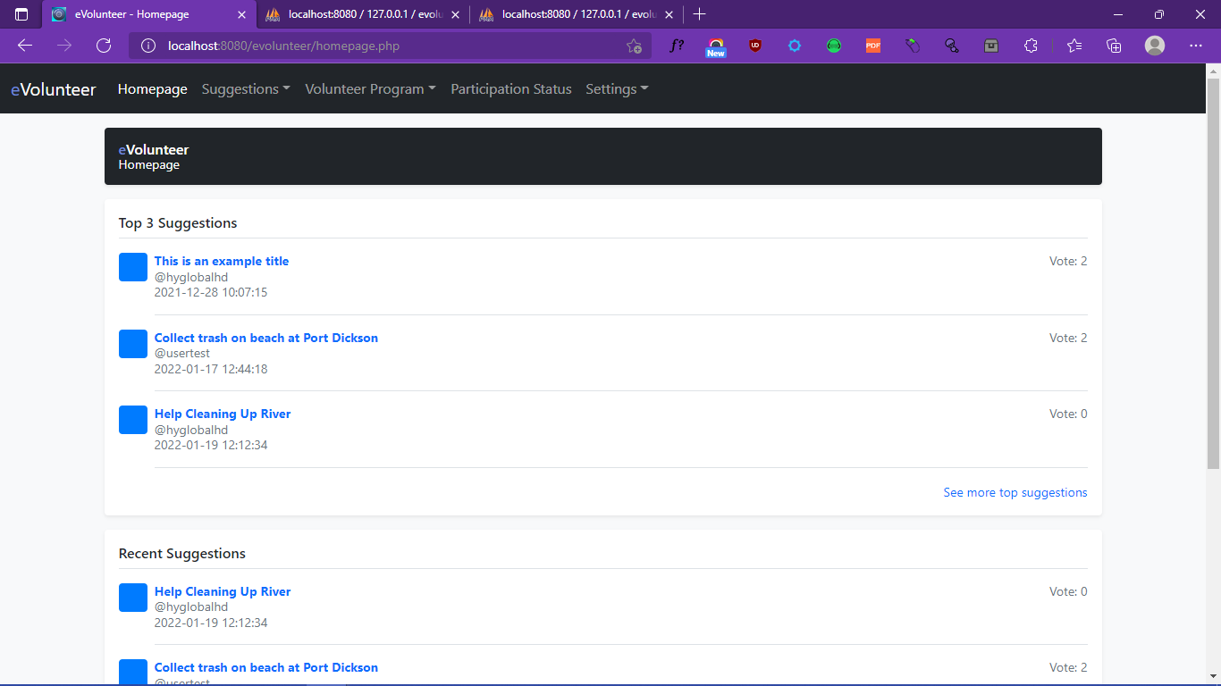

1. Top Suggestions

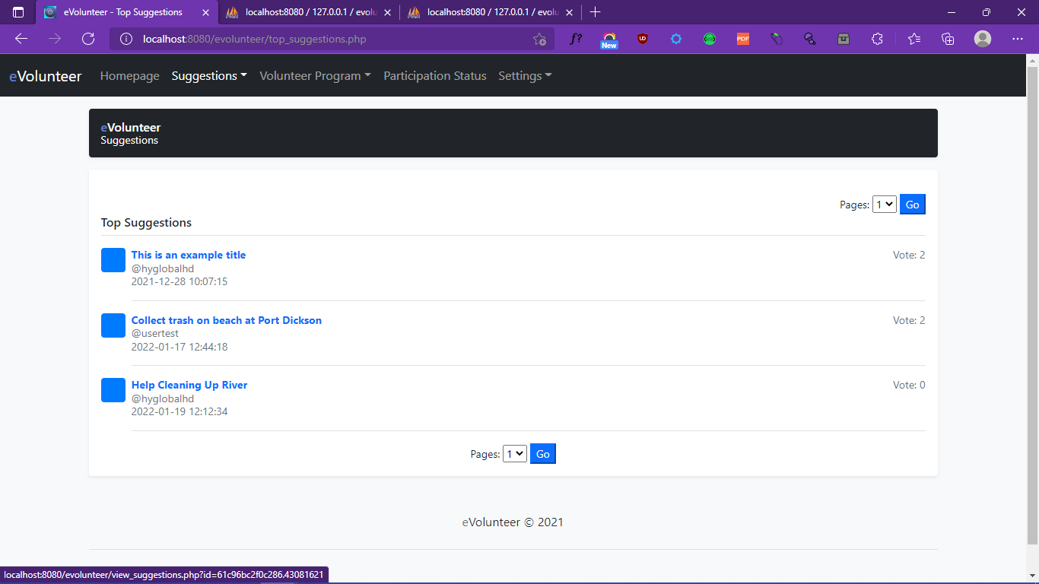

1. Recent Suggestions

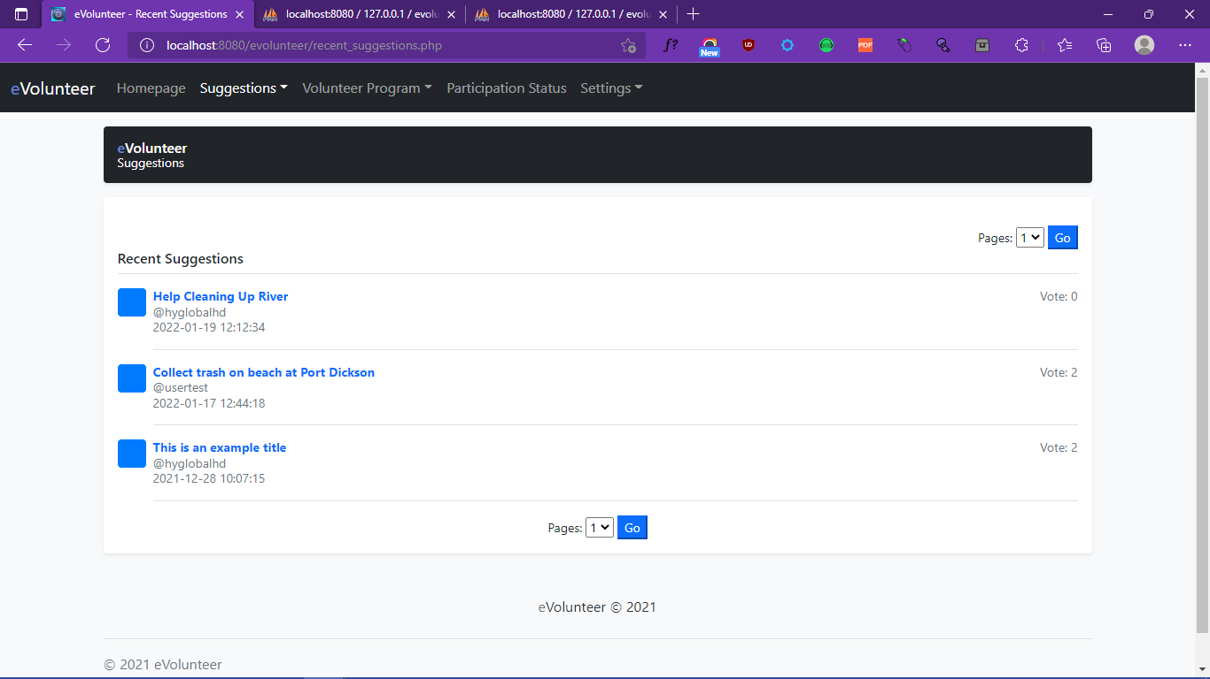

1. View Suggestions

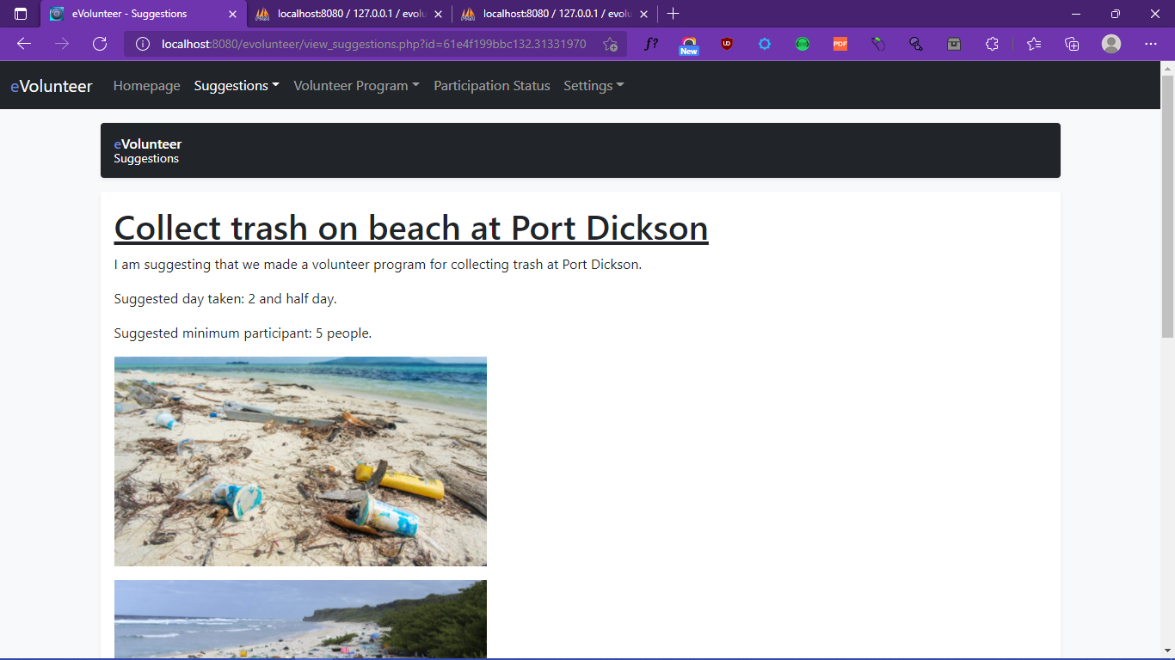

1. All Volunteer Program

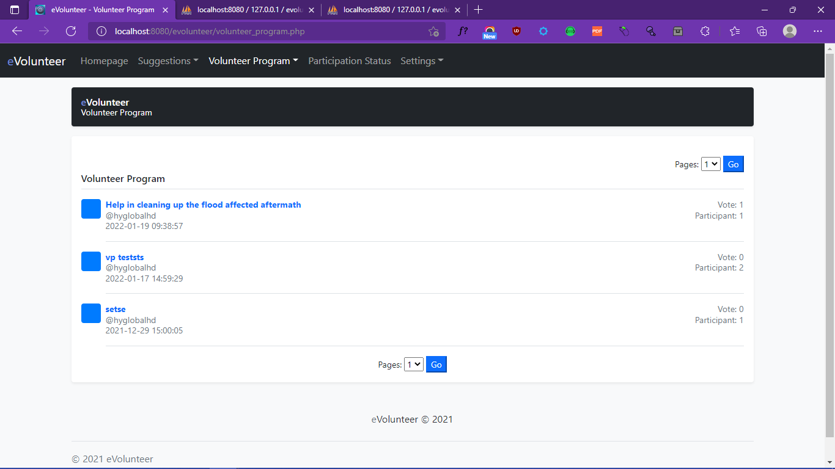

1. View Volunteer Program

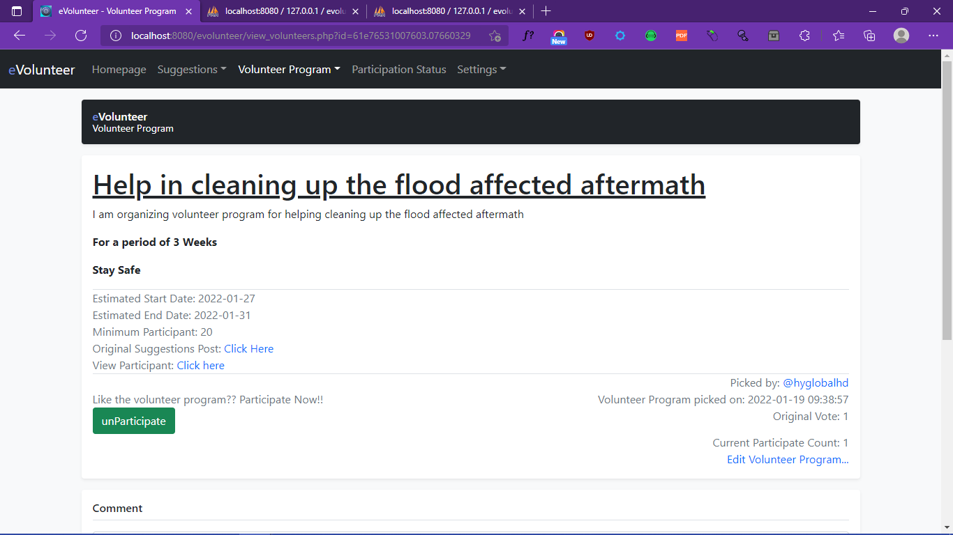

1. View Participant List

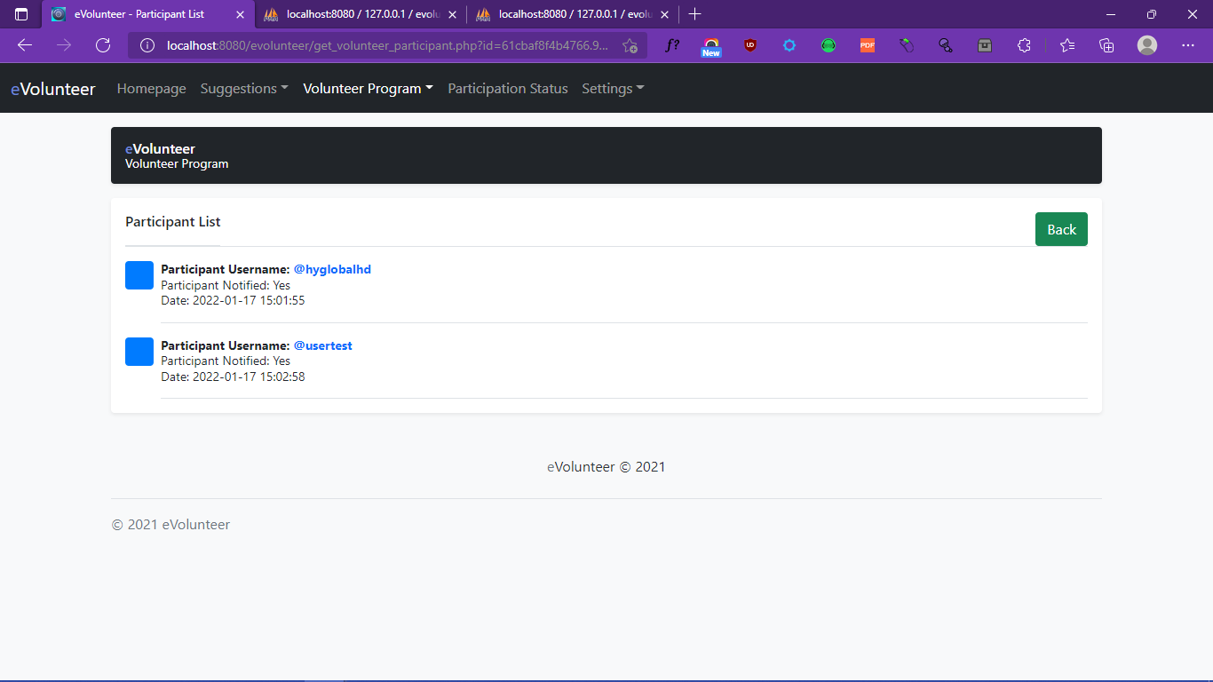

1. View Participant Status

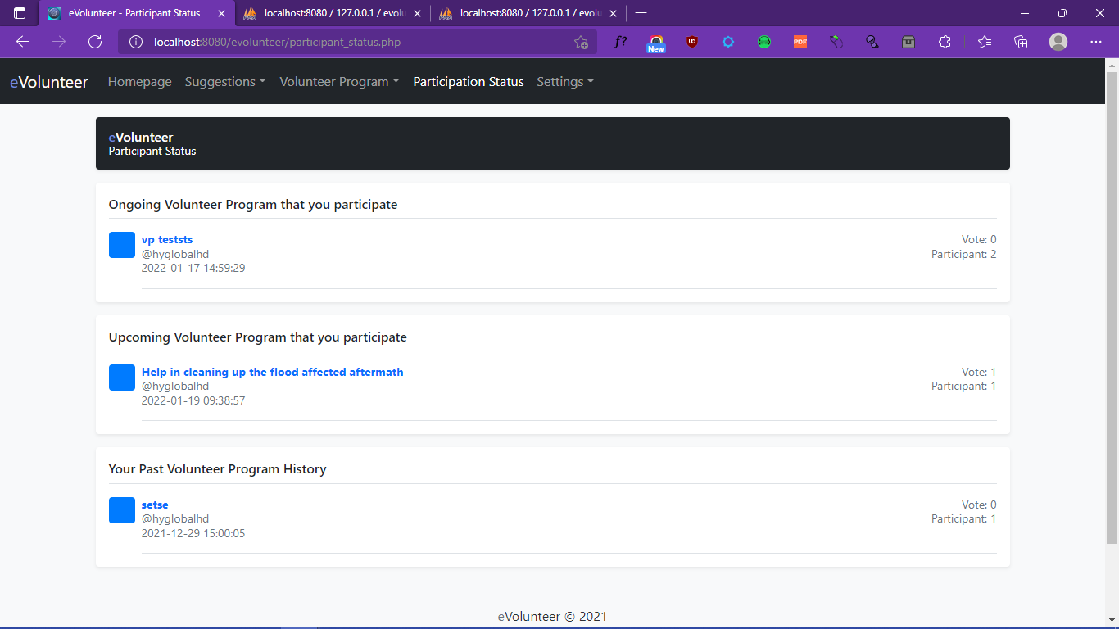

1. View User Profile

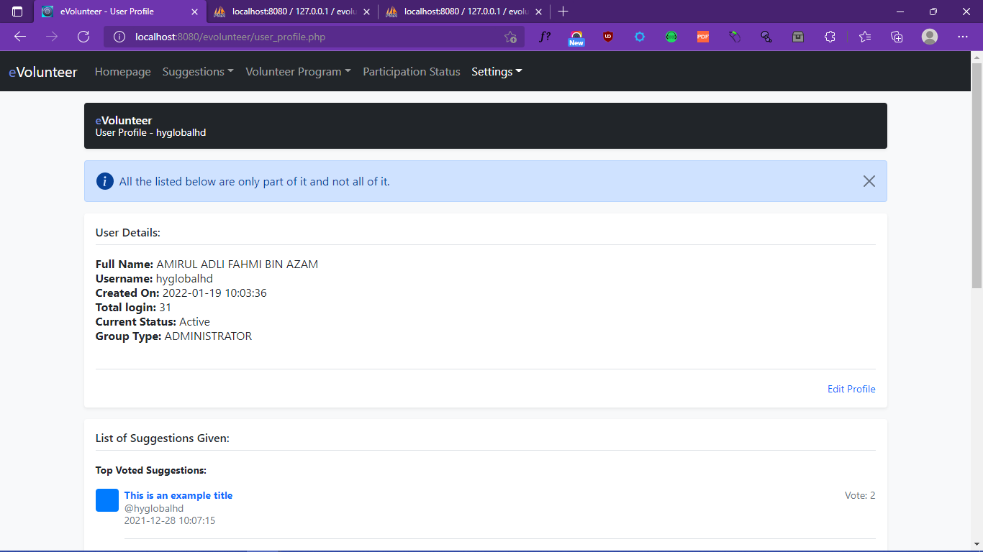

1. View Achievement

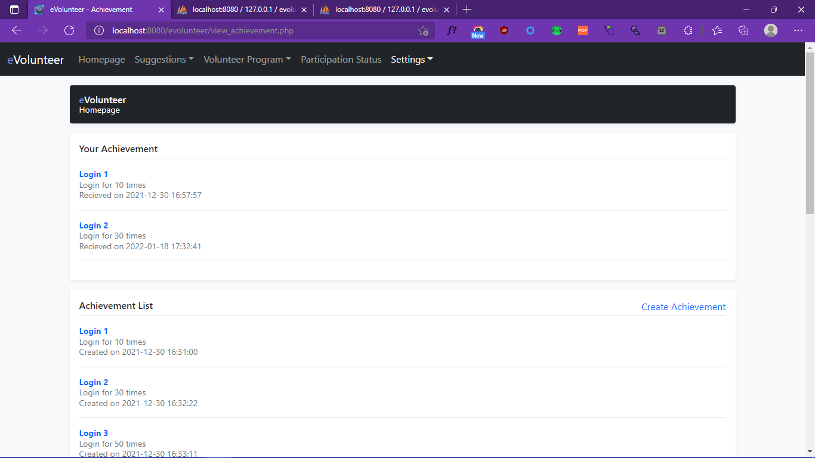

1. Ban/UnBan User

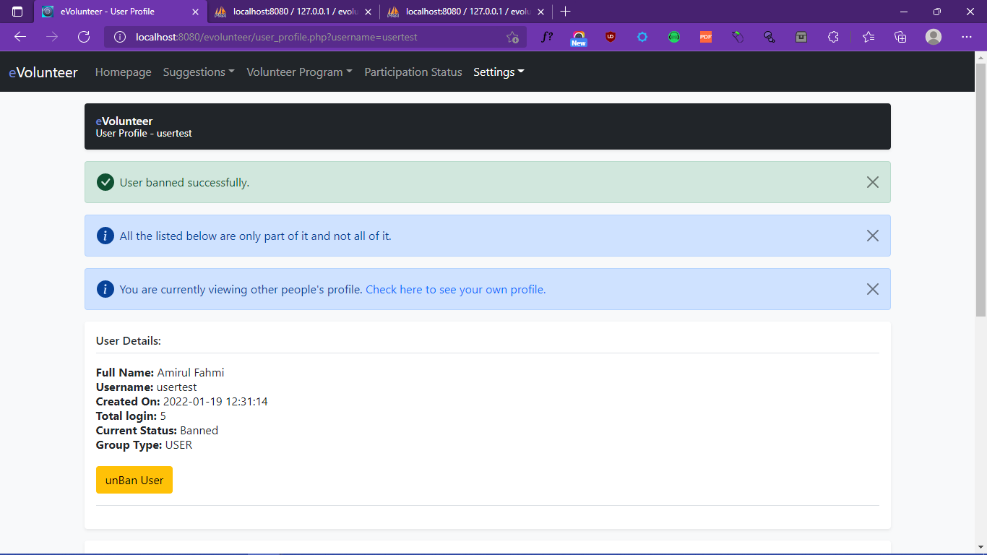

1. Create Achievement

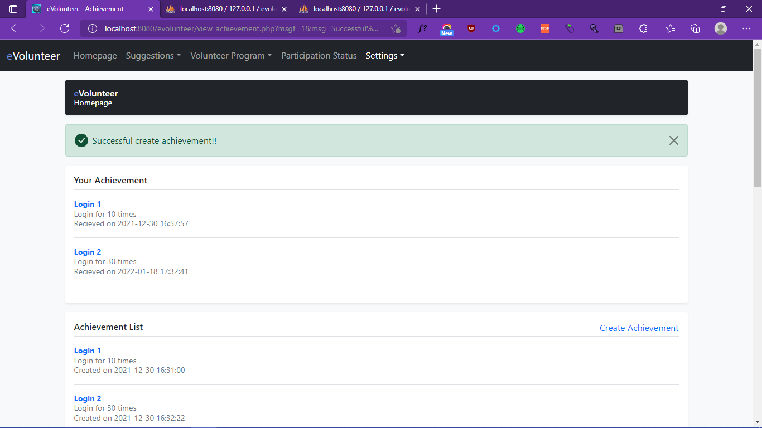

1. Logout

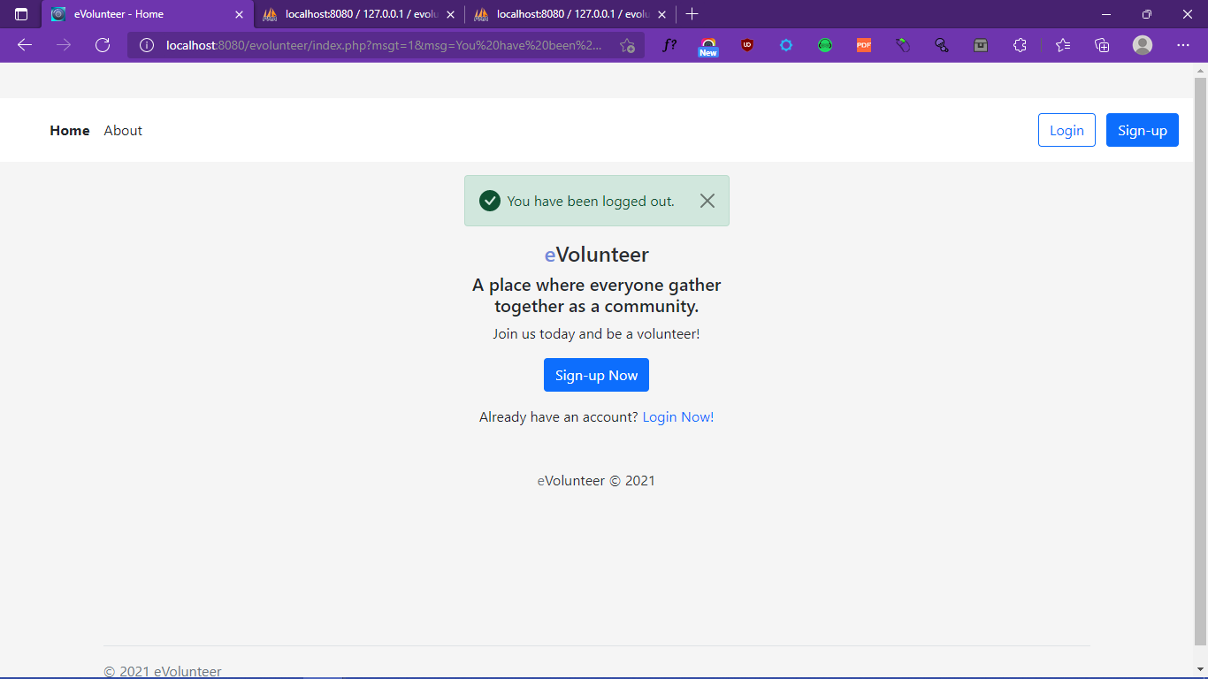

1. About

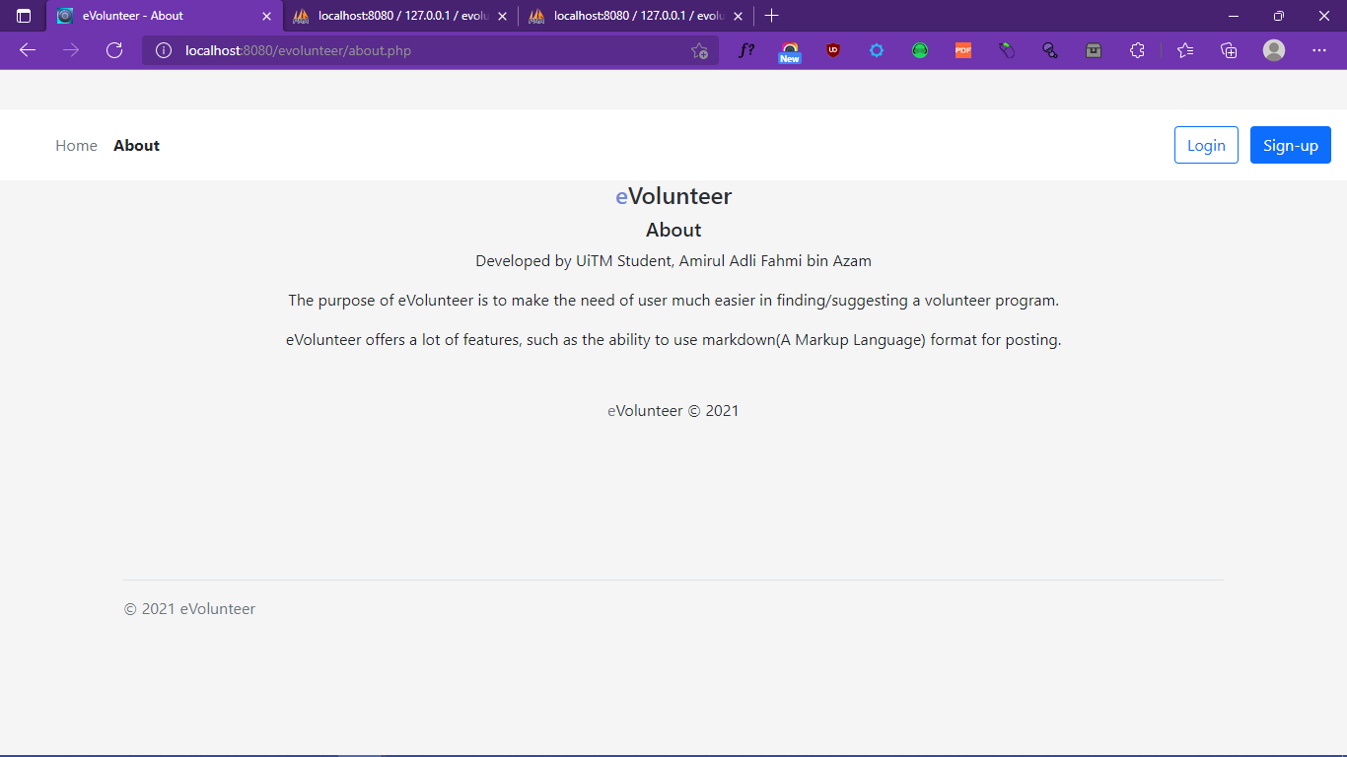

* 1. **Process Interface**

1. Registration

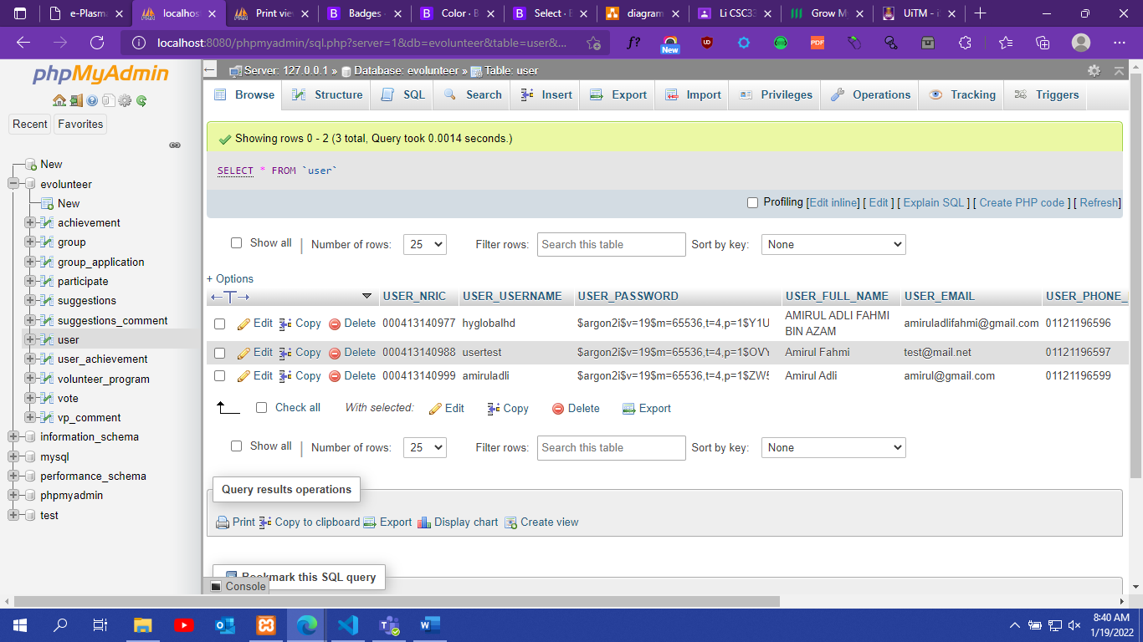

1. Create Suggestions

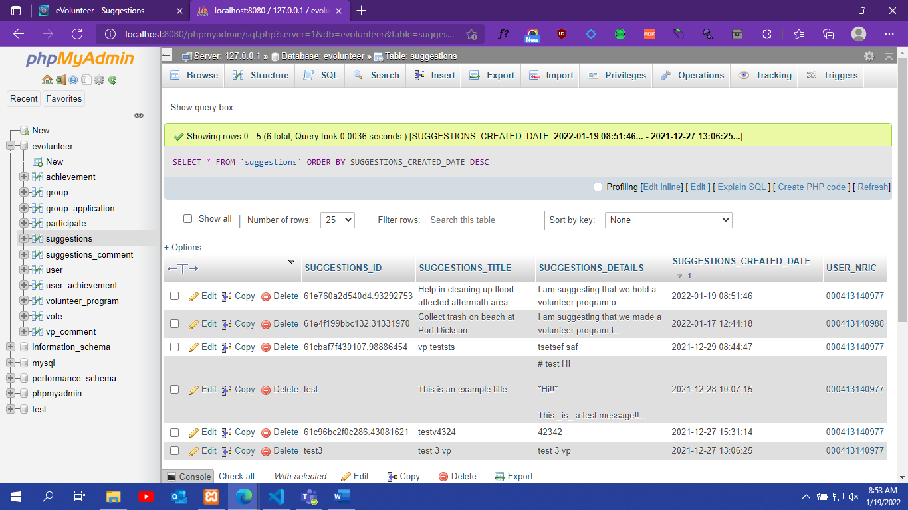

1. Edit/Delete Suggestions

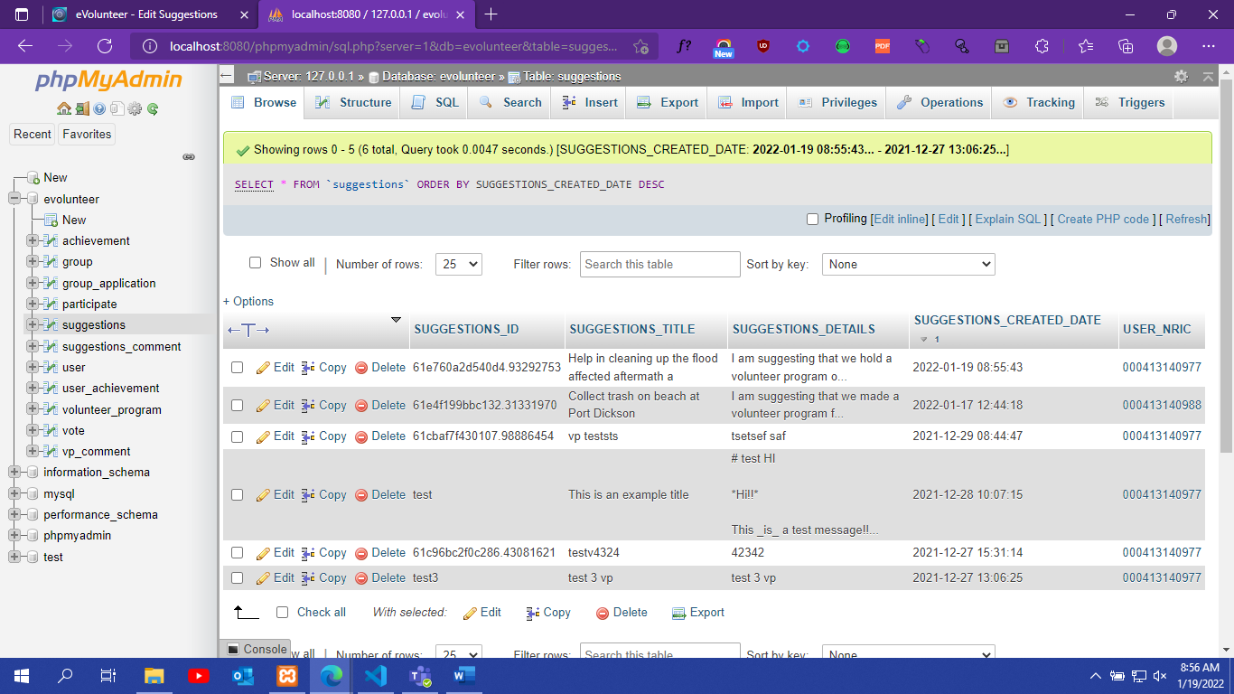

1. Vote/UnVote

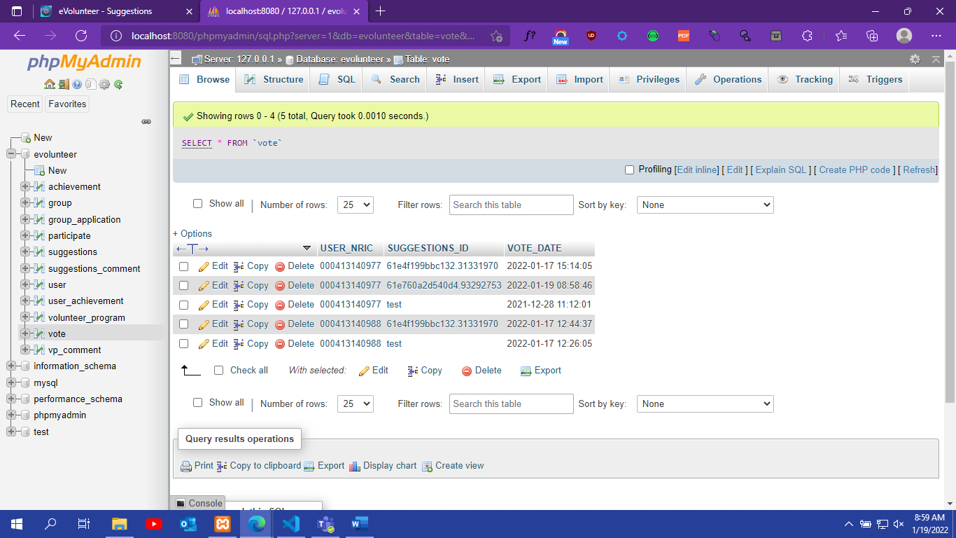

1. New Suggestions Comment

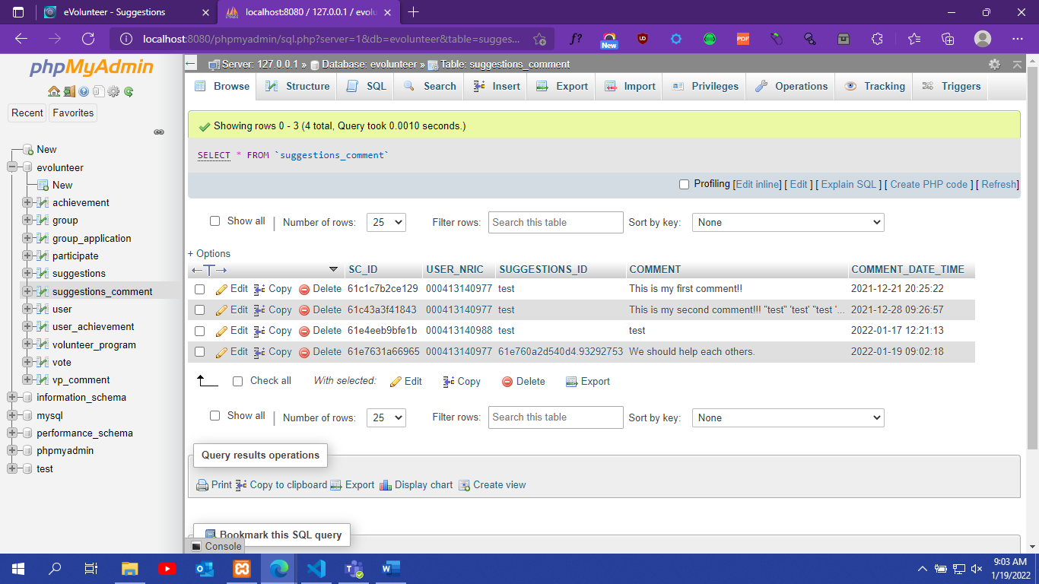

1. Edit/Delete Suggestions Comment

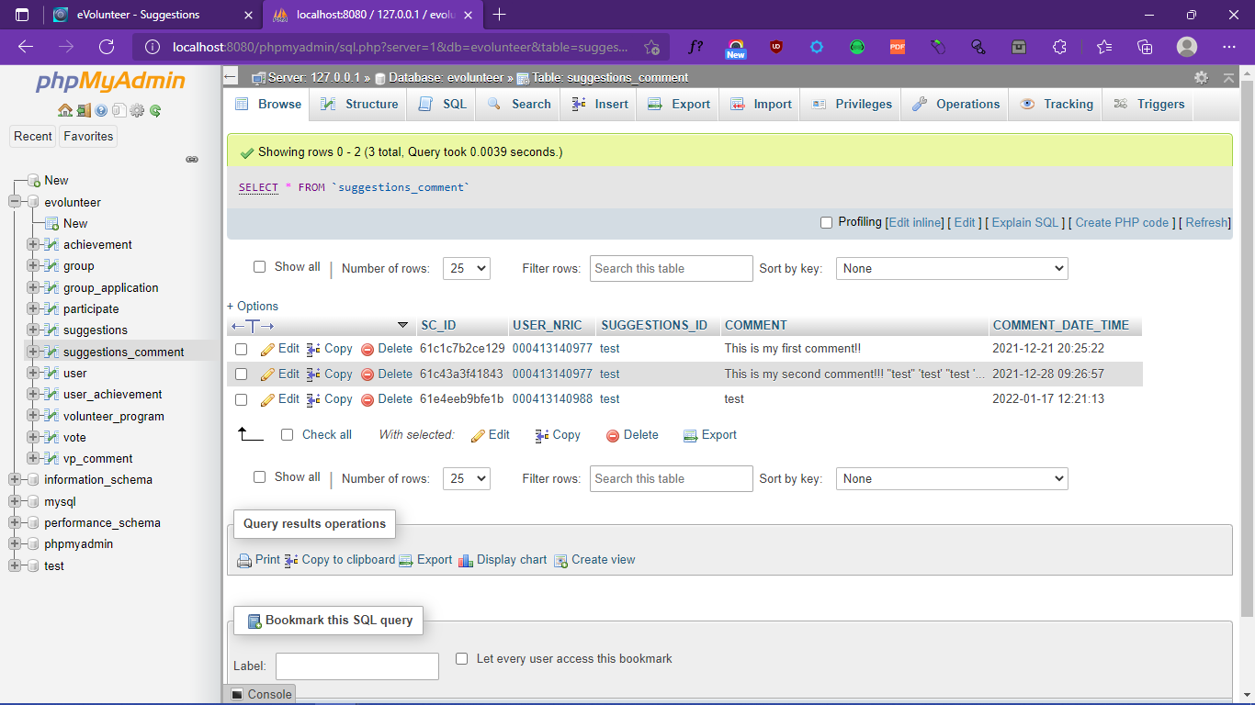

1. Create Volunteer Program

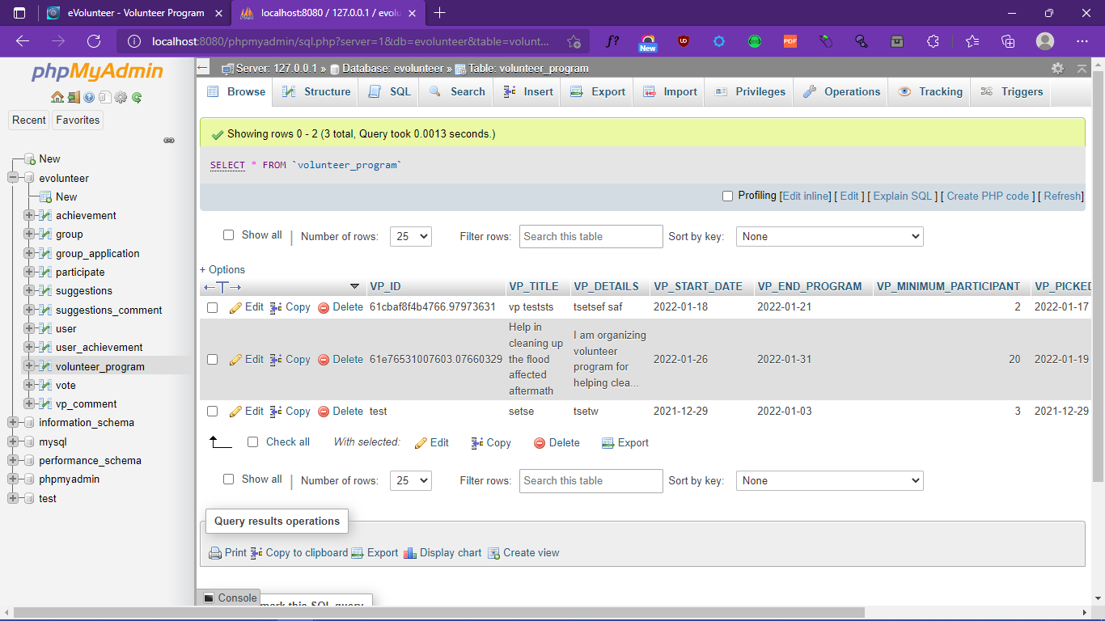

1. Edit/Delete Volunteer Program

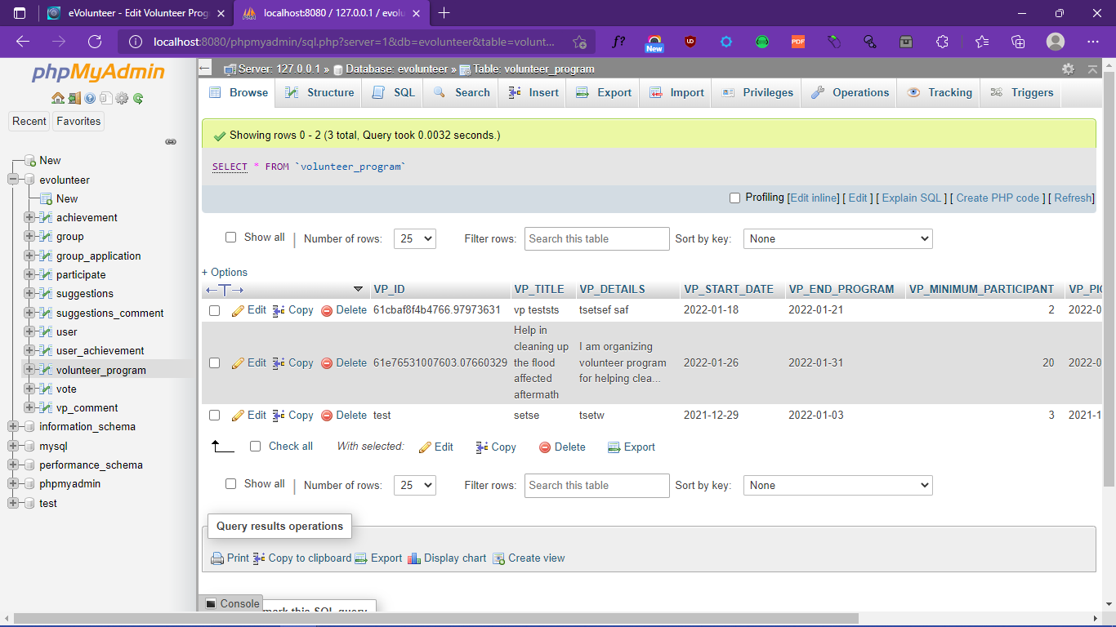

1. Participate/UnParticipate Volunteer Program

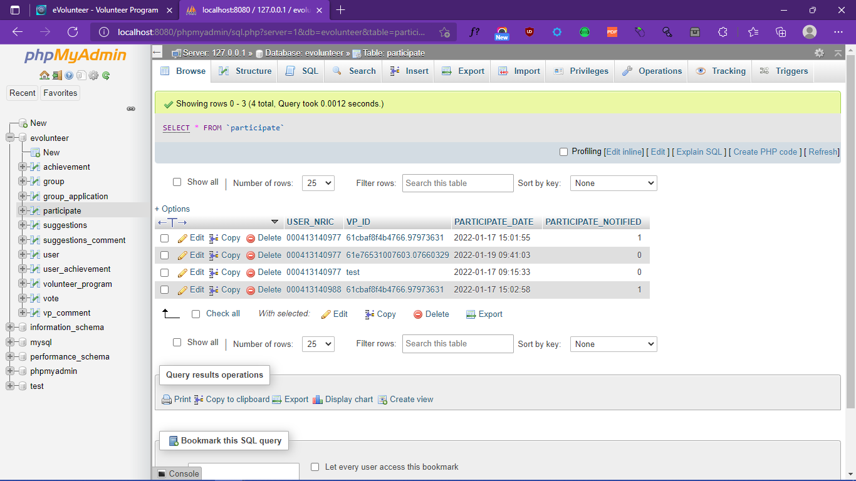

1. New Volunteer Program Comment

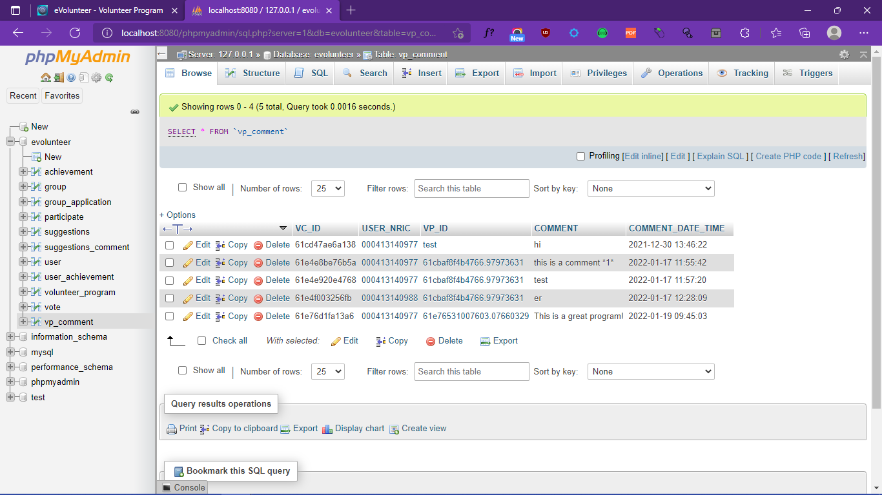

1. Edit/Delete Volunteer Program Comment

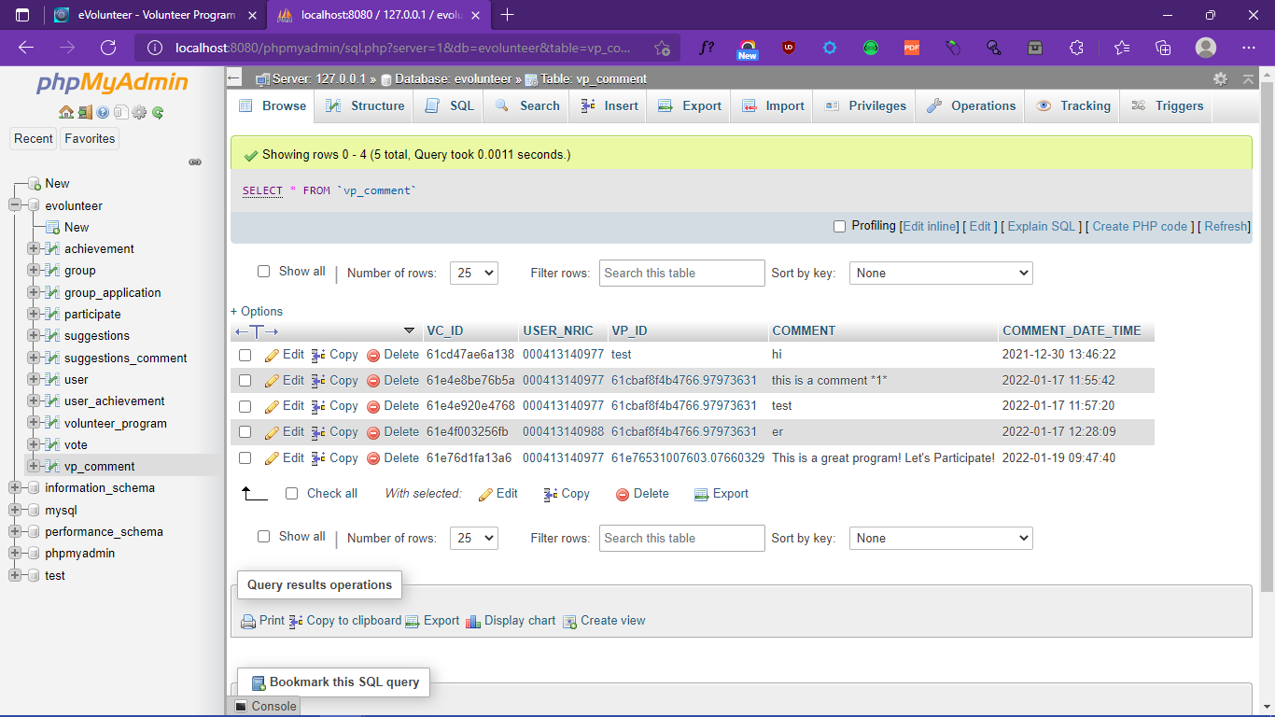

1. Update User Profile

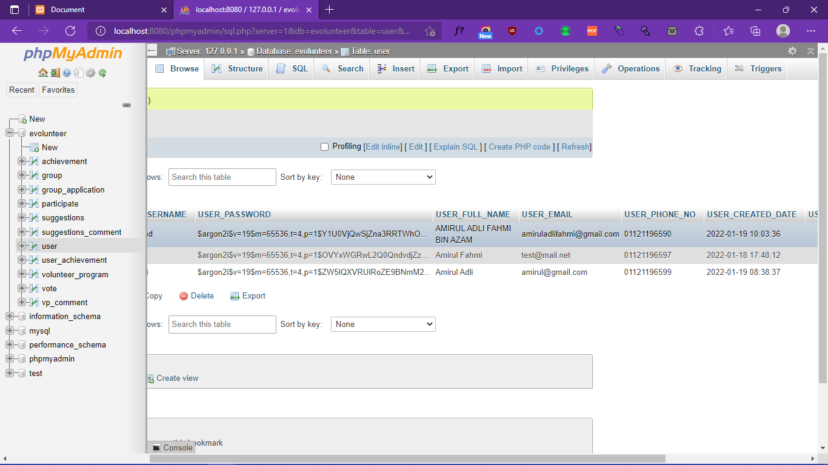

1. Group Application Apply

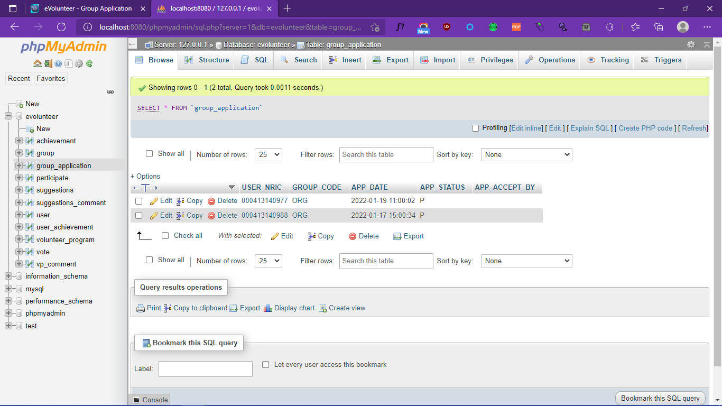

1. Admin Group Application Edit

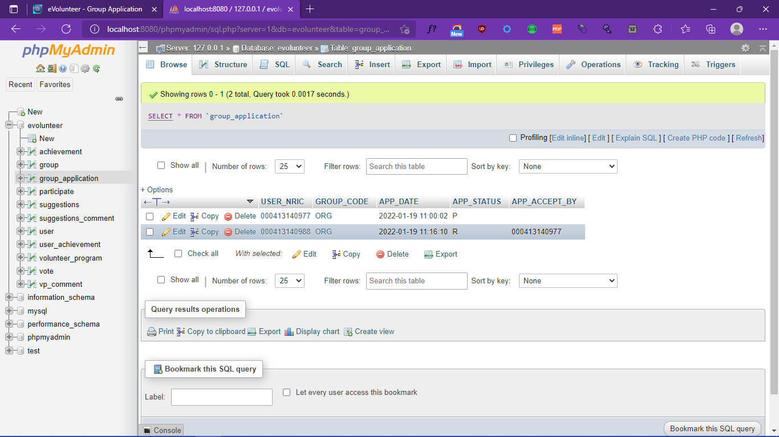

1. User Group Application Cancel

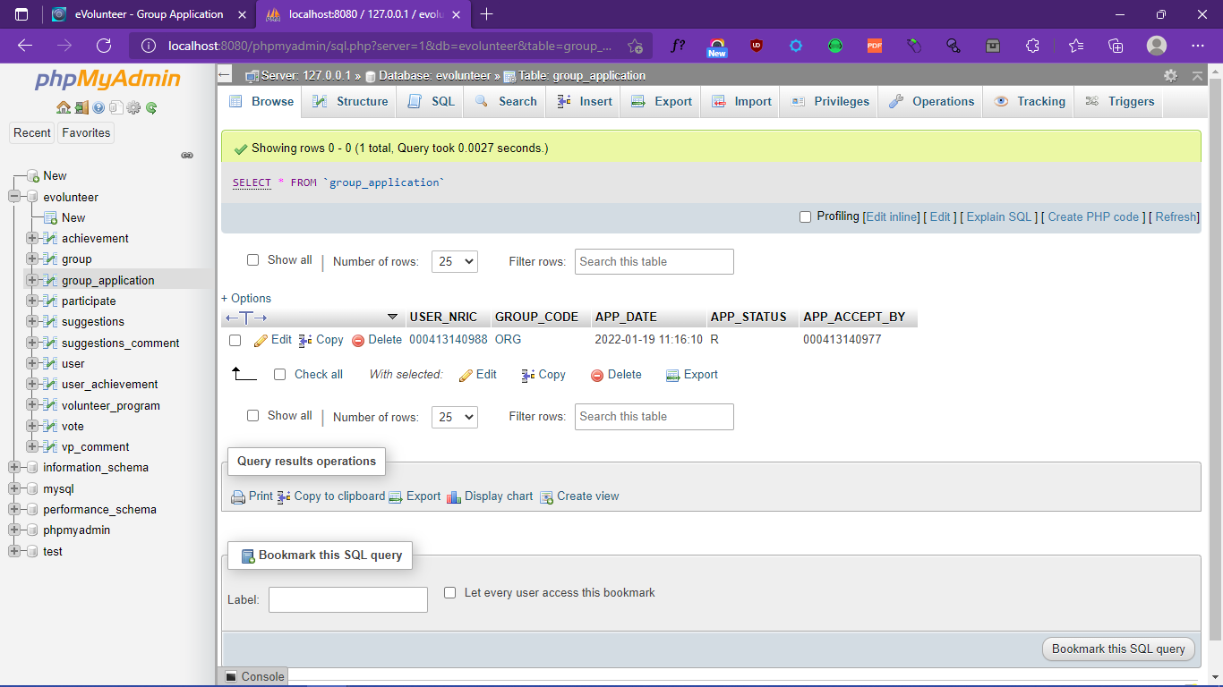

1. Ban/UnBan User

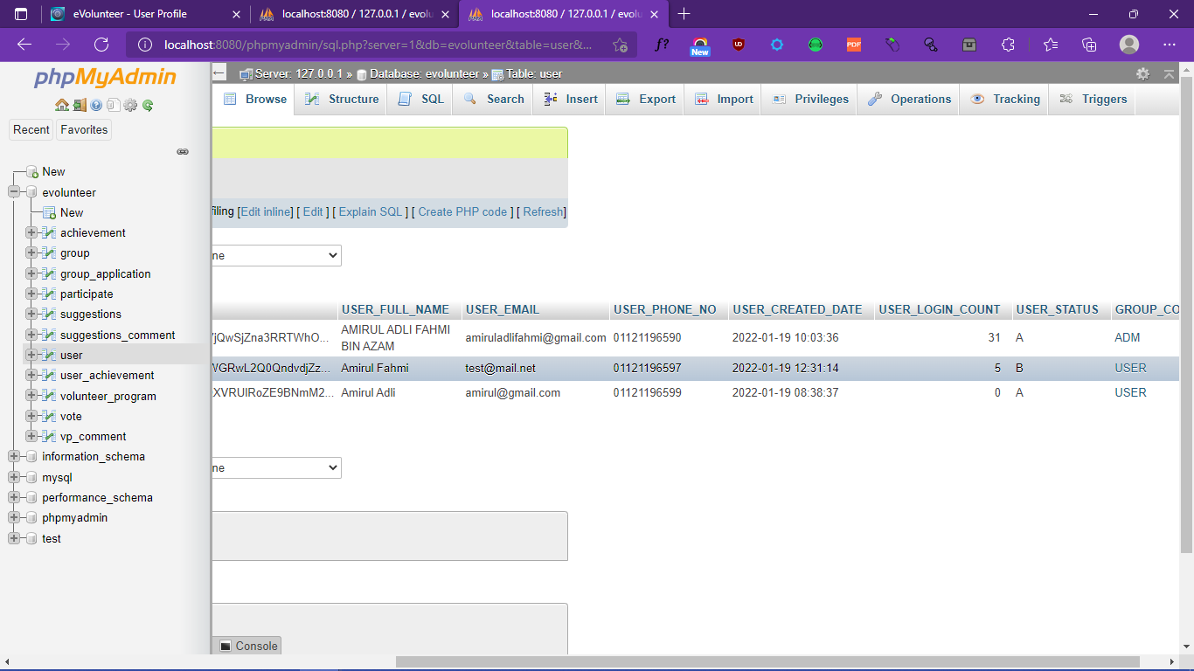

1. Create Achievement

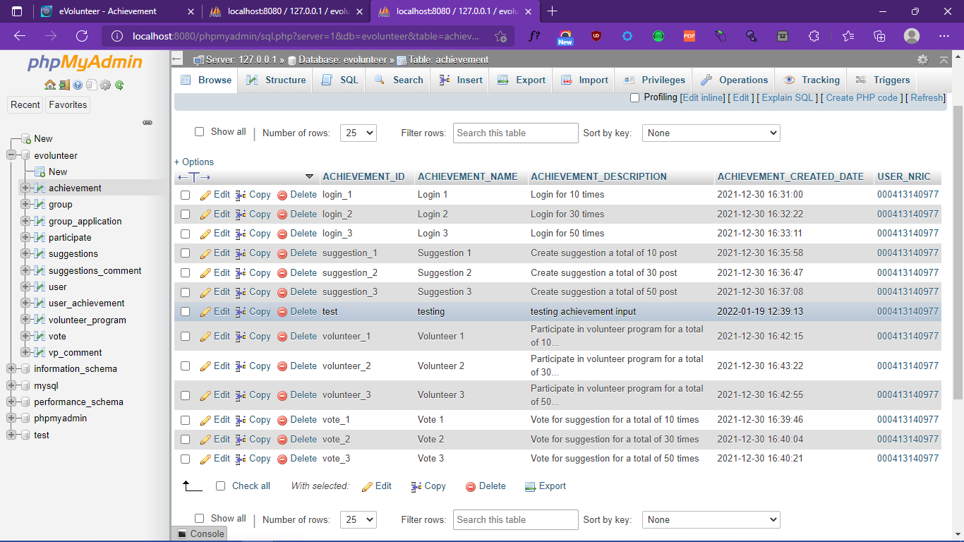

1. **System Testing**
   1. **Introduction**

To make sure the project is presentable for deployment, we have run system testing to ensure that the system is not vulnerable with the security flaws, fixing bugs that does not output the required results, fix logic errors, make sure validation is correct, and test all the functions to ensure there is no bugs.

* 1. **Test summary**
     1. **Unit Testing**

The test for unit testing has been conducted by taking a part of the essentials functions for testing and have been checked to accomplish the anticipated results.

* + 1. **Integration Testing**

For the integration testing, we have done the test on the module to see if the system integrating properly or otherwise, by combining the module and test it as a group.

* + 1. **System testing**

For the system testing, we have tested the whole web-application system to check whether the system is properly working or otherwise as per requirement set.

* 1. **Test assessment**

|  |  |  |
| --- | --- | --- |
| **Organization Responsibility** | **Signature** | **Date** |
| *Customer/customer representative (if applicable)* |  |  |
| *Project Manager* |  |  |
| *Software Tester #1* |  |  |
| *Software Tester #2 (if applicable)* |  |  |
| *Software Tester #3 (if applicable)* |  |  |
| *Software Tester #4 (if applicable)* |  |  |
| *Software Tester #5 (if applicable)* |  |  |
| *Examiner/Lecturer #1* | A picture containing text  Description automatically generated  Norasmah Jaafar | 24th January 2022 |
| *Examiner/Lecturer #2 (if applicable)* |  |  |

* 1. **Test result**

|  |  |
| --- | --- |
| **Test Case #: 1** | **Test Case Name: Registration** |
| **System: eVolunteer** | **Subsystem:** |
| **Designed by: Amirul Adli Fahmi bin Azam** | **Design Date: 19 January 2022** |
| **Executed by: Amirul Adli Fahmi bin Azam** | **Execution Date: 19 January 2022** |
| **Short Description: To test registration system functions and input filters** | |

|  |  |  |  |  |
| --- | --- | --- | --- | --- |
| **Step** | **Action** | **Expected System Response** | **Pass/Fail** | **Comment** |
| 1 | Click Sign-Up Button | Direct user to user registration page | Pass |  |
| 2 | Click Register Button | Does not do anything, and highlight user to input data | Pass |  |
| 3 | Enter existing data into the input and try to register | Shows an error that the user is already registered and recommend user to login instead. | Pass |  |
| 4 | Input a wrong input format for email | It highlights the input box, and tells user that the input is in wrong format | Pass |  |
| 5 | Put input not the same as confirm password | Tells the user that the password is not matched. | Pass |  |
| 6 | Put input except one input box and submit the input | Highlight the missing input, and ask the user to input the data | Pass |  |
| 7 | Input unregistered data and register the user | Will process the data and try to input the user data into the database, and if successful it will tell the user that their registration is successful and give a link to login. | Pass |  |

1. **Findings And Observations**
   1. **System strengths**

After many runs, testing and observations, I have found the system strengths, such as:

1. Security in user inputs, it checks the user input and required the user to enter the required format.
2. Unique ability of using Markdown(Markup Language) to enhance the user experience in making a post.
3. Simple and user-friendly interfaces, that allow user to understand on how to use it after a few runs.
4. Innovative features, such as achievements and commenting subsystems.
5. Input security, where the ability to allow and accept unique characters such as single colon and double colon and can’t have security flaws like SQL injections.
6. Security checker where user without enough permission, can’t access the pages. (E.g., Normal user trying to edit other user information).
   1. **System weaknesses**

Even the most secured places have their own weaknesses, and after some detailed researched on the systems, I have found the system weakness, such as:

1. The use message in the URL, that directly can put a message to the pages. This can be a major flaw, as it could be used for people to put a bad message.
2. Because of using NRIC number as a unique identifier, the user scope is limited to user with NRIC only.
3. There is no user confirmation that the user is the one with the said NRIC number.
4. Doesn’t have any confirmation or verifications to the email and phone numbers.
   1. **Recommendation for future works**

The web-application project, eVolunteer, could expands furthers and have many features. Some of the recommendation I would love to see for the future is that.

1. The ability to preview the user post, before creating a new post.
2. Word filter and malicious link checker, or moderator to check on user.
3. Leveling subsystem, where user can have their own level, and shows their level next to their username. To level, user must do specific tasks beforehand (E.g., Obtain achievements, join many programs, and posting). This is to make the application more engaging for user.
4. To also allow Markdown(Markup Language) to be enable for comment sections.
5. To push a notification to user email, and phone.
6. If wanting to make the web-application more international, it is recommended to use username for the primary key, and not use NRIC number.
7. Make a report subsystem, to allow user to report another user for misbehaviors.
8. Add more details on about page, for example, give a user manual on how to use the web-application.
9. Add a subcategory system, to filter out the post via regions, to ensure that user can find post based on their regions.
10. If the future has plans on having server room, it is recommended to allow user to have their own user profile.
11. Enhance the communication for organizer and their participants, add a communication subsystem.
12. Give more features for organizer, such as the ability to mark the participant is present or not.
13. Add a verification, to verify the user email and phone numbers.
14. Add latest news section, where it takes from news media, to give user an idea on the latest news.
    1. **Conclusion**

After many runs, and observations, I have come to the conclusions. The system has a lot of potentials in how it operates and design, the systems have great strengths that could also be improved, and the weakness can be easily overcome by doing some changes. The system also could potentially hold greats features, for it to become more complete and allow the best user experience. The system idea itself is very helpful and useful for the society, let take the recent accidents with floods, with the systems, we can easily gather people to volunteer and let user have a platform where they could help each other’s.

**8.0 REFERENCES**

Bootstrap Team, Bootstrap Documentation, 2021  
 <https://getbootstrap.com/> .Retrace at 7 July 2021.

Markedjs, Marked Documentation, 2021  
 <https://marked.js.org/> .Retrace at 10 September 2021.

PA Thoits, LN Hewitt - Journal of health and social behavior, 2001  
 <https://www.jstor.org/stable/3090173> .Retrace at 14 December 2021.

RB Freeman - Journal of Labor Economics, 1997  
 [https://www.journals.uchicago.edu](https://www.journals.uchicago.edu/doi/abs/10.1086/209859) .Retrace at 23 October 2021.

**Appendix**

**achievement**

|  |  |  |  |  |  |  |
| --- | --- | --- | --- | --- | --- | --- |
| **Column** | **Type** | **Null** | **Default** | **Links to** | **Comments** | **Media (MIME) type** |
| ACHIEVEMENT_ID *(Primary)* | varchar(15) | No |  |  |  |  |
| ACHIEVEMENT_NAME | varchar(50) | No |  |  |  |  |
| ACHIEVEMENT_DESCRIPTION | varchar(150) | Yes | *NULL* |  |  |  |
| ACHIEVEMENT_CREATED_DATE | timestamp | No | current_timestamp() |  |  |  |
| USER_NRIC | varchar(12) | No |  | user -> USER_NRIC |  |  |

**Indexes**

| **Keyname** | **Type** | **Unique** | **Packed** | **Column** | **Cardinality** | **Collation** | **Null** | **Comment** |
| --- | --- | --- | --- | --- | --- | --- | --- | --- |
| PRIMARY | BTREE | Yes | No | ACHIEVEMENT_ID | 11 | A | No |  |
| achievement_ibfk_1 | BTREE | No | No | USER_NRIC | 2 | A | No |  |

**group**

|  |  |  |  |  |  |  |
| --- | --- | --- | --- | --- | --- | --- |
| **Column** | **Type** | **Null** | **Default** | **Links to** | **Comments** | **Media (MIME) type** |
| GROUP_CODE *(Primary)* | varchar(15) | No |  |  |  |  |
| GROUP_NAME | varchar(50) | Yes | *NULL* |  |  |  |
| GROUP_REMARKS | varchar(100) | Yes | *NULL* |  |  |  |
| GROUP_CREATED_BY | varchar(12) | No |  |  |  |  |
| GROUP_CREATED_DATE | timestamp | No | current_timestamp() |  |  |  |

**Indexes**

| **Keyname** | **Type** | **Unique** | **Packed** | **Column** | **Cardinality** | **Collation** | **Null** | **Comment** |
| --- | --- | --- | --- | --- | --- | --- | --- | --- |
| PRIMARY | BTREE | Yes | No | GROUP_CODE | 2 | A | No |  |

**group_application**

|  |  |  |  |  |  |  |
| --- | --- | --- | --- | --- | --- | --- |
| **Column** | **Type** | **Null** | **Default** | **Links to** | **Comments** | **Media (MIME) type** |
| USER_NRIC *(Primary)* | varchar(12) | No |  | user -> USER_NRIC |  |  |
| GROUP_CODE *(Primary)* | varchar(15) | No |  | group -> GROUP_CODE |  |  |
| APP_DATE | timestamp | No | current_timestamp() |  |  |  |
| APP_STATUS | varchar(10) | No |  |  |  |  |
| APP_ACCEPT_BY | varchar(12) | Yes | *NULL* |  |  |  |

**Indexes**

| **Keyname** | **Type** | **Unique** | **Packed** | **Column** | **Cardinality** | **Collation** | **Null** | **Comment** |
| --- | --- | --- | --- | --- | --- | --- | --- | --- |
| PRIMARY | BTREE | Yes | No | USER_NRIC | 1 | A | No |  |
| GROUP_CODE | 1 | A | No |
| GROUP_CODE | BTREE | No | No | GROUP_CODE | 1 | A | No |  |

**participate**

|  |  |  |  |  |  |  |
| --- | --- | --- | --- | --- | --- | --- |
| **Column** | **Type** | **Null** | **Default** | **Links to** | **Comments** | **Media (MIME) type** |
| USER_NRIC *(Primary)* | varchar(12) | No |  | user -> USER_NRIC |  |  |
| VP_ID *(Primary)* | varchar(25) | No |  | volunteer_program -> VP_ID |  |  |
| PARTICIPATE_DATE | timestamp | No | current_timestamp() |  |  |  |
| PARTICIPATE_NOTIFIED | tinyint(1) | No |  |  |  |  |

**Indexes**

| **Keyname** | **Type** | **Unique** | **Packed** | **Column** | **Cardinality** | **Collation** | **Null** | **Comment** |
| --- | --- | --- | --- | --- | --- | --- | --- | --- |
| PRIMARY | BTREE | Yes | No | USER_NRIC | 2 | A | No |  |
| VP_ID | 2 | A | No |
| VP_ID | BTREE | No | No | VP_ID | 2 | A | No |  |

**suggestions**

|  |  |  |  |  |  |  |
| --- | --- | --- | --- | --- | --- | --- |
| **Column** | **Type** | **Null** | **Default** | **Links to** | **Comments** | **Media (MIME) type** |
| SUGGESTIONS_ID *(Primary)* | varchar(25) | No |  |  |  |  |
| SUGGESTIONS_TITLE | varchar(50) | No |  |  |  |  |
| SUGGESTIONS_DETAILS | longtext | No |  |  |  |  |
| SUGGESTIONS_CREATED_DATE | timestamp | No | current_timestamp() |  |  |  |
| USER_NRIC | varchar(12) | No |  | user -> USER_NRIC |  |  |

**Indexes**

| **Keyname** | **Type** | **Unique** | **Packed** | **Column** | **Cardinality** | **Collation** | **Null** | **Comment** |
| --- | --- | --- | --- | --- | --- | --- | --- | --- |
| PRIMARY | BTREE | Yes | No | SUGGESTIONS_ID | 5 | A | No |  |
| suggestions_ibfk_1 | BTREE | No | No | USER_NRIC | 2 | A | No |  |

**suggestions_comment**

|  |  |  |  |  |  |  |
| --- | --- | --- | --- | --- | --- | --- |
| **Column** | **Type** | **Null** | **Default** | **Links to** | **Comments** | **Media (MIME) type** |
| SC_ID *(Primary)* | varchar(15) | No |  |  |  |  |
| USER_NRIC | varchar(12) | No |  | user -> USER_NRIC |  |  |
| SUGGESTIONS_ID | varchar(25) | No |  | suggestions -> SUGGESTIONS_ID |  |  |
| COMMENT | text | No |  |  |  |  |
| COMMENT_DATE_TIME | timestamp | No | current_timestamp() |  |  |  |

**Indexes**

| **Keyname** | **Type** | **Unique** | **Packed** | **Column** | **Cardinality** | **Collation** | **Null** | **Comment** |
| --- | --- | --- | --- | --- | --- | --- | --- | --- |
| PRIMARY | BTREE | Yes | No | SC_ID | 3 | A | No |  |
| SUGGESTIONS_ID | BTREE | No | No | SUGGESTIONS_ID | 3 | A | No |  |
| suggestions_comment_ibfk_2 | BTREE | No | No | USER_NRIC | 3 | A | No |  |

**user**

|  |  |  |  |  |  |  |
| --- | --- | --- | --- | --- | --- | --- |
| **Column** | **Type** | **Null** | **Default** | **Links to** | **Comments** | **Media (MIME) type** |
| USER_NRIC *(Primary)* | varchar(12) | No |  |  |  |  |
| USER_USERNAME | varchar(50) | No |  |  |  |  |
| USER_PASSWORD | char(100) | No |  |  |  |  |
| USER_FULL_NAME | varchar(150) | No |  |  |  |  |
| USER_EMAIL | varchar(100) | No |  |  |  |  |
| USER_PHONE_NO | varchar(15) | No |  |  |  |  |
| USER_CREATED_DATE | timestamp | No | current_timestamp() |  |  |  |
| USER_LOGIN_COUNT | int(11) | No |  |  |  |  |
| USER_STATUS | char(5) | No |  |  |  |  |
| GROUP_CODE | varchar(15) | No |  | group -> GROUP_CODE |  |  |

**Indexes**

| **Keyname** | **Type** | **Unique** | **Packed** | **Column** | **Cardinality** | **Collation** | **Null** | **Comment** |
| --- | --- | --- | --- | --- | --- | --- | --- | --- |
| PRIMARY | BTREE | Yes | No | USER_NRIC | 3 | A | No |  |
| GROUP_CODE | BTREE | No | No | GROUP_CODE | 3 | A | No |  |

**user_achievement**

|  |  |  |  |  |  |  |
| --- | --- | --- | --- | --- | --- | --- |
| **Column** | **Type** | **Null** | **Default** | **Links to** | **Comments** | **Media (MIME) type** |
| USER_NRIC *(Primary)* | varchar(12) | No |  | user -> USER_NRIC |  |  |
| ACHIEVEMENT_ID *(Primary)* | varchar(15) | No |  | achievement -> ACHIEVEMENT_ID |  |  |
| RECEIVED_DATE | timestamp | No | current_timestamp() |  |  |  |

**Indexes**

| **Keyname** | **Type** | **Unique** | **Packed** | **Column** | **Cardinality** | **Collation** | **Null** | **Comment** |
| --- | --- | --- | --- | --- | --- | --- | --- | --- |
| PRIMARY | BTREE | Yes | No | USER_NRIC | 0 | A | No |  |
| ACHIEVEMENT_ID | 0 | A | No |
| ACHIEVEMENT_ID | BTREE | No | No | ACHIEVEMENT_ID | 0 | A | No |  |

**volunteer_program**

|  |  |  |  |  |  |  |
| --- | --- | --- | --- | --- | --- | --- |
| **Column** | **Type** | **Null** | **Default** | **Links to** | **Comments** | **Media (MIME) type** |
| VP_ID *(Primary)* | varchar(25) | No |  |  |  |  |
| VP_TITLE | varchar(50) | No |  |  |  |  |
| VP_DETAILS | longtext | No |  |  |  |  |
| VP_START_DATE | date | No |  |  |  |  |
| VP_END_PROGRAM | date | No |  |  |  |  |
| VP_MINIMUM_PARTICIPANT | int(11) | No |  |  |  |  |
| VP_PICKED_DATE | timestamp | No | current_timestamp() |  |  |  |
| USER_NRIC | varchar(12) | No |  | user -> USER_NRIC |  |  |
| SUGGESTIONS_ID | varchar(25) | No |  | suggestions -> SUGGESTIONS_ID |  |  |

**Indexes**

| **Keyname** | **Type** | **Unique** | **Packed** | **Column** | **Cardinality** | **Collation** | **Null** | **Comment** |
| --- | --- | --- | --- | --- | --- | --- | --- | --- |
| PRIMARY | BTREE | Yes | No | VP_ID | 2 | A | No |  |
| USER_NRIC | BTREE | No | No | USER_NRIC | 2 | A | No |  |
| volunteer_program_ibfk_2 | BTREE | No | No | SUGGESTIONS_ID | 2 | A | No |  |

**vote**

|  |  |  |  |  |  |  |
| --- | --- | --- | --- | --- | --- | --- |
| **Column** | **Type** | **Null** | **Default** | **Links to** | **Comments** | **Media (MIME) type** |
| USER_NRIC *(Primary)* | varchar(12) | No |  | user -> USER_NRIC |  |  |
| SUGGESTIONS_ID *(Primary)* | varchar(25) | No |  | suggestions -> SUGGESTIONS_ID |  |  |
| VOTE_DATE | timestamp | No | current_timestamp() |  |  |  |

**Indexes**

| **Keyname** | **Type** | **Unique** | **Packed** | **Column** | **Cardinality** | **Collation** | **Null** | **Comment** |
| --- | --- | --- | --- | --- | --- | --- | --- | --- |
| PRIMARY | BTREE | Yes | No | USER_NRIC | 4 | A | No |  |
| SUGGESTIONS_ID | 4 | A | No |
| SUGGESTIONS_ID | BTREE | No | No | SUGGESTIONS_ID | 4 | A | No |  |

**vp_comment**

|  |  |  |  |  |  |  |
| --- | --- | --- | --- | --- | --- | --- |
| **Column** | **Type** | **Null** | **Default** | **Links to** | **Comments** | **Media (MIME) type** |
| VC_ID *(Primary)* | varchar(15) | No |  |  |  |  |
| USER_NRIC | varchar(12) | No |  | user -> USER_NRIC |  |  |
| VP_ID | varchar(25) | No |  | volunteer_program -> VP_ID |  |  |
| COMMENT | text | No |  |  |  |  |
| COMMENT_DATE_TIME | timestamp | No | current_timestamp() |  |  |  |

**Indexes**

| **Keyname** | **Type** | **Unique** | **Packed** | **Column** | **Cardinality** | **Collation** | **Null** | **Comment** |
| --- | --- | --- | --- | --- | --- | --- | --- | --- |
| PRIMARY | BTREE | Yes | No | VC_ID | 3 | A | No |  |
| VP_ID | BTREE | No | No | VP_ID | 3 | A | No |  |
| vp_comment_ibfk_1 | BTREE | No | No | USER_NRIC | 3 | A | No |  |